# EvaluationGroup, LLC

**Community Transformation Grant**

**Evaluation Report**

for

Beltrami, Clearwater, Hubbard, Lake of the Woods,

Mahnomen, Norman, and Polk County

Community Health Boards

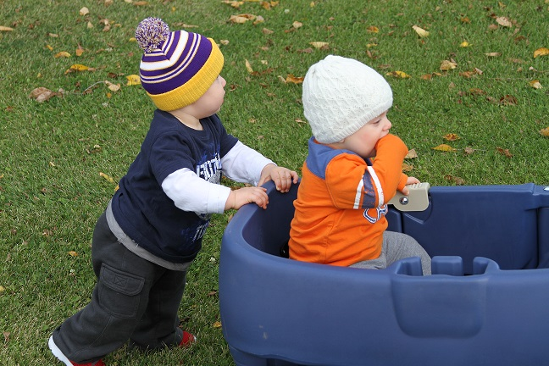

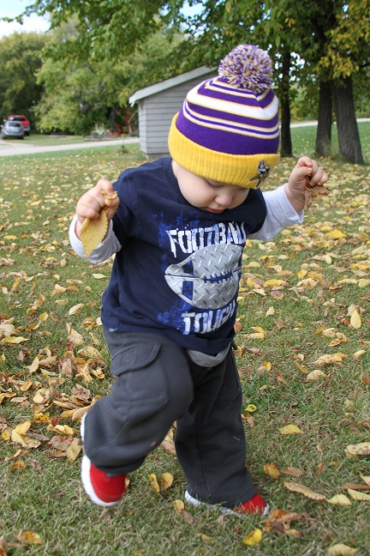

April

2014

Authored by

Garth Kruger, Ph.D.

EvaluationGroup,LLC * 29337 310th Ave NW * Warren, MN 56762

Tel (218) 437-8435 * e-mail *gkruger@evaluationgroupllc.com*

**Table of Contents**

Executive Summary i-ii

Background1-8

Selected Regional Demographics that Impact Outcomes and Affect Program Planning8-19

Population per square mile2

Educational levels2-3

Unemployment3

Regional income and poverty4-12

Healthcare center locations13

MNSS and BRFSS methodology14-15

Behaviors that impact health15-26

Adult smoking15

Smoking during pregnancy15-16

Youth tobacco use16-18

Overweight/obese/physical activity18-20

Adults overweight18

Youth overweight18-19

Youth obesity20

Adult physical activity20

Adult physical inactivity21

Access to exercise21

Physical activity in youth22

Consumption of fresh fruits and vegetables23

Breastfeeding rates24

Adult health status25

Poor physical health days25

Diabetes26

Cancer age adjusted death rates26

Heart disease27

Diabetic screening27

Mammography screening28

Qualitative Research Findings29-30

Ideas, Suggestions and Recommendations 31-34

Appendices35-52

Appendix A: BRFSS Methodology35

Appendix B: Ideas for Target Market Segmentation36-45

Appendix C: Concept/Variance Map Categories46-52

**CTG Evaluation Report**

***Executive Summary***

**Physical Fitness…**

*In Youth*

* Regarding physical activity, the percentage of youth engaging in ‘none at all’ during a typical week has trended lower over time, moving significantly lower from 13.3% in 2007 to 9.4% in 2013.
  + It is also currently lower than what is found across the rest of the state (12.4%).
* The Region is significantly higher in terms of the percentage of youth who are meeting physical activity guidelines (19.3%) compared to the rest of the state (16.6%).
* The percentage of youth who are overweight in the Region has been generally increasing over the past six years, moving from 12.7% in 2007 to 16.6% in 2013.
  + The percentage of youth meeting the classification for obesity has changed little from 11.9% in 2007 to 12.2% in 2013; and current rates of obesity in the region are significantly higher than the state average of 9.6%.

*In Adults*

* Both the 2010 and 2014 County Health Rankings released by MDH reveal that all of the counties in the Region have higher rates of adult obesity compared to statewide.
  + No statistically significant decreases or increases in obesity were evidenced between the BRFSS administration time periods in either the Region or statewide.
* The percent of adults aged 20 and over reporting no leisure-time physical activity increased from 20% in 2008 to 26% in 2010 and appears to be somewhat higher than the state average of 20%.
  + Estimates suggest that approximately 31,947 residents may not be getting any form of meaningful leisure time physical activity.

**Tobacco Use…**

*By Youth*

* Self-reported tobacco use in the Regions’ youth (past 30 days) is down significantly over the past six years from 37.8% in 2007 to 23.9% in 2013,
  + However, tobacco use is still higher than the state average of 18.8%.
  + Smokeless tobacco use also appears to be declining, moving from 16.0% in 2007 to 13.2% in 2013; and is down significantly from its peak in 2010 at 21.4%.
    - Smokeless tobacco use by youth in the region is still nearly twice that of youth across the rest of the state.

*By Adults*

* Smoking in the region is higher than compared to the rest of the state. Slight decreases in adult smoking rates are suggested; however no differences between time frames rise to the level of statistical significance.
  + According to telephone survey research conducted during the fall of 2013, approximately 25% of the Regions’ residents were found to be current smokers. This finding was in line with the regional average of approximately 21% found in the BRFSS 2006-12 datasets.
  + Smokeless tobacco use in adults for this same telephone survey was estimated at 21%.
* The percent of pregnant women who smoke is higher in the region than in comparison to the state.
  + The percent of pregnant women who smoked ranges somewhere between 12% (Norman) and 52% (Mahnomen) with the state average at 10%.

**Overall Health of Adults…**

* 11% of the population in Minnesota indicated ‘fair or poor health’ between 3-year time intervals of BRFSS administrations.
  + With the possible exception of Clearwater County, the confidence intervals presented lie well within the statewide averages and so it is possible that no real differences between the state and Region exist on this issue.
  + Similarly, all of the counties in the Region with data reported fewer than average poor physical health days.
* BRFSS age adjusted estimates of diabetes within the region reveal that the prevalence of the disease may be elevated compared to the statewide average.
* According to Minnesota Vital Statistics, age adjusted death rates for heart disease in the Region are substantially higher year over year compared to the state on average.

**Healthy Eating in Youth…**

* Youth consumption of 5 or more servings of fresh fruits/vegetables per day has remained generally unchanged over time, ranging around 12-13%.
  + Compared to the statewide average of 17.7%, there appears to be continued room for progress in fresh fruit and vegetable consumption opportunities for youth.

**Background**

**What is the purpose of this grant?** The Community Transformation Grants (CTG) is designed to improve health and control health care spending.

* The grant supports community efforts to reduce the physical and financial burden of chronic disease felt by Minnesota families, businesses, and government. CTG will help reduce unsustainable growth in health care costs. Reductions in risk factors for chronic disease could result in significant cost savings.
* Nationally, treating chronic diseases consumes 75 percent of the $2 trillion spent each year for health care costs. The Community Transformation Grant will strengthen Minnesota’s economy by reducing chronic disease related-disability and improving worker productivity.
* Although behavioral and environmental factors that could be addressed through prevention are responsible for approximately 70 percent of deaths in the U.S., only three percent of health spending currently goes toward prevention, compared to 97 percent for treatment of illness.

**Who else received a CTG?** The Centers for Disease Control and Prevention awarded CTG grants to 61 states and communities, totaling more than $103 million. Seven counties working together as a group were awarded CTG funds in Northwest Minnesota and included Beltrami, Clearwater; Hubbard, Lake of the Woods, Mahnomen, Norman and Polk counties. The total amount of award was $250,000 over a five-year period.

**What is the funding period?** The five-year CTG project period is 9/30/2011 – 9/29/2016.

**What are the CTG guiding principles?**

* Maximize health impact through prevention
* Improve health equity
* Expand the evidence base for policy, systems and environmental changes that improve health

**What are the strategic directions for CTG?**

* Tobacco-free living
* Active living and healthy eating
* Evidence-based quality clinical and other preventive services, specifically prevention and control of high blood pressure and high cholesterol
* Social and emotional wellness
* Healthy and safe physical environment

More information may be found at <http://www.cdc.gov/communitytransformation>

**Selected Regional Demographics that Impact Outcomes and Affect Program Planning**

***Population/Density***

Population statistics per square mile reveal that only Lake of the Woods (LOW) county meets the designation of being a frontier population (six or fewer people per square mile) <http://www.frontierus.org/> .

|  |  |  |
| --- | --- | --- |
| **County** | **Persons per sq. mile** | **Population 2011** |
| LOW | 3 | 3,929 |
| Norman | 8 | 6,869 |
| Mahnomen | 9 | 5,456 |
| Clearwater | 9 | 8,838 |
| Polk | 16 | 31,456 |
| Beltrami | 18 | 45,670 |
| Hubbard | 22 | 20,658 |
| Minnesota | 65 | 5.34 million |
| USA | 84 | 302 million |
| World | 117 (not including water) | 7.74 billion |

Source: U. S Census Bureau statistics, 2010/11 population estimates

***Educational Levels***

Educational levels of area residents are substantially lower than in comparison to the rest of the state. Between 39-54% of the population in the region aged 25 and older has less than or equal to a high school education or equivalent compared to 37% of the population statewide.



Between 14-28% of the population in the region aged 25 and older has a bachelor’s degree or higher compared to 31% of the population statewide.



***Unemployment Rate***

Year over year, the 5-year unemployment rate within Clearwater (12.1%) is substantially higher than the state average of 5.86%.

|  |  |  |  |  |  |  |
| --- | --- | --- | --- | --- | --- | --- |
| **Unemployment rate - annual average**  **2005-2009** | | | | | |  |
|  | 2006 | 2007 | 2008 | 2009 | 2010 | 5-yr avg. |
| Statewide | 4 | 4.6 | 5.4 | 8.0 | 7.3 | 5.86 |
| Polk | 4.7 | 4.5 | 5 | 6.2 | 5.5 | 5.18 |
| Norman | 5.0 | 5.1 | 5.7 | 6.7 | 6.4 | 5.78 |
| LOW | 4.7 | 5.3 | 6.2 | 7.8 | 6.4 | 6.08 |
| Beltrami | 5.2 | 6.1 | 6.9 | 8.9 | 8.2 | 7.06 |
| Mahnomen | 5.6 | 6.7 | 7.4 | 8.0 | 8.1 | 7.16 |
| Hubbard | 5.6 | 6.4 | 7.7 | 10.3 | 9.8 | 7.96 |
| Clearwater | 9.8 | 10.4 | 11.6 | 15.1 | 13.6 | 12.1 |

***Regional Income and Poverty***

***Median Income***

**The U.S. Median income from 2006-2010 was $51,914. In Minnesota during the same time frame it was $57,243 (**<http://quickfacts.census.gov/qfd/states/27000.html>**). Statistics show that median income in the region ranges between 15-33% lower ($9,267 to $19,684) than the statewide average. *Across a working lifetime of 40 years this means that a household in the middle of the income distribution potentially brings home $370,000 to $787,000 less than other households across the state.* Income levels by township do not currently exist in a reliable form known to the author at this time. Presently, county-level estimates provide the most reliable form of assessment. To see a clearer picture of how median household income is spread across the study region, see Figure 1 on the following pages. Median income is depicted as a function of standard deviations from the average and depicted by zip-code (a far greater resolution than by county and a clearer depiction of where the income deficiencies exist.). The data show a swath spanning from the south west to the northeast (highlighted by a circle) where median income is the lowest. This low income area should be explored more closely when targeting/reaching out to low income groups.**

|  |  |
| --- | --- |
| **County** | **Median Household Income** |
| Mahnomen | $39,442 |
| Clearwater | $41,896 |
| LOW | $41,979 |
| Norman | $45,000 |
| Beltrami | $44,038 |
| Hubbard | $45,623 |
| Polk | $49,859 |
| Minnesota | $59,126 |
| USA | $51,914 |
| World | $7,000* |

**\*Average income**

2008-2012 Time frame

***Per Capita Income***

Per capita income or income per person is a measure of mean [income](http://en.wikipedia.org/wiki/Income) within an economic aggregate, such as a country, city or county. It is calculated by taking a measure of all sources of income in the aggregate (such as GDP or Gross National Income) and dividing it by the total population. It does not attempt to reflect the distribution of income or wealth (<http://en.wikipedia.org/wiki/Per_capita_income>).

Per capita income has several weaknesses as a measurement of prosperity, including:

* As it is a mean value, it does not reflect income distribution. If the distribution of income within a country is skewed, a small wealthy class can increase per capita income far above that of the majority of the population. In this respect median income is a more useful measure of prosperity than per capita income, because it is less influenced by the outliers.
* Economic activity that does not result in monetary income, such as service provided within the family, or for barter; is usually not counted. The importance of these services varies widely among different economies.

|  |  |  |  |  |  |
| --- | --- | --- | --- | --- | --- |
| **Total per capita income 2004-2008** | | | | | |
|  | 2005 | 2006 | 2007 | 2008 | 2009 |
| Clearwater | $22,486 | $23,559 | $24,859 | $27,228 | $28,738 |
| Mahnomen | $29,150 | $31,129 | $33,515 | $38,578 | $29,718 |
| LOW | $24,677 | $25,304 | $25,389 | $30,559 | $30,922 |
| Beltrami | $25,571 | $26,244 | $27,549 | $29,633 | $30,976 |
| Hubbard | $26,208 | $27,417 | $27,984 | $31,784 | $32,423 |
| Polk | $27,502 | $28,277 | $30,420 | $36,854 | $36,080 |
| Norman | $27,414 | $29,149 | $33,572 | $44,339 | $38,282 |
| Statewide | $37,290 | $38,859 | $41,105 | $42,953 | $41,854 |

***Current Poverty Guidelines***

**The current Poverty Guidelines published by the Federal Register are shown in the table below. These figures are not the figures the Census Bureau uses to calculate the number of individuals in poverty. The figures that the Census Bureau uses are the poverty thresholds (**[www.aspe.hhs.gov/POVERTY/14poverty.cfm](http://www.aspe.hhs.gov/POVERTY/14poverty.cfm) **).**

|  |  |
| --- | --- |
| **2014 Poverty Guidelines for the 48 Contiguous States and the District of Columbia\*** | |
| **Persons in family/household** | **Poverty guideline** |
| **1** | $11,670 |
| **2** | 15,730 |
| **3** | 19,790 |
| **4** | 23,850 |
| **5** | 27,910 |
| **6** | 31,970 |
| **7** | 36,930 |
| **8** | 40,090 |
|  | |

*For families/households with more than 8 persons, add $3,960 for each additional person.

The negative consequences of poverty typically have the greatest adverse impact on the elderly and the young. In some areas of the region, the 8% more of population is aged 65 and older compared to the rest of the state; furthermore the region has 1% to 8 % more of its elderly population living at home alone. Elderly people living at home are more at-risk for accidents or injuries than those living with others. Living alone may imply greater functional ability, but injuries and outcomes can be worse, especially if the person cannot rise from the ground. Living alone has been shown to be a risk factor for falls although part of this effect appears to be related to certain types of housing older people may occupy (Health Evidence Network, 2004).

|  |  |  |  |
| --- | --- | --- | --- |
| **Number and percent of people aged 65 years and older 2010** | | | |
|  | **Population 65+ years** | | **Percent of households in which the resident is 65 and over and living alone** |
| **Number** | **Percent** |
| Norman | 1,465 | 21 | 16.3 |
| Hubbard | 4,245 | 21 | 12.0 |
| LOW | 821 | 20 | 12.4 |
| Clearwater | 1,621 | 19 | 13.3 |
| Polk | 5,220 | 17 | 12.9 |
| Mahnomen | 855 | 16 | 11.6 |
| Beltrami | 5,754 | 13 | 10.4 |
| **Statewide** | **683,121** | **12.9** | **9.7** |

Those elderly (>age 65) who are in poverty are a targeted sub-population of many CTG and SHIP activities. Figures 4 and 5 on pages 11 and 12 depict by zip code the percentage of elderly in poverty in addition to a finer resolution of ½ standard deviation (from the poverty average) increments. The greater the deviation is from average, the greater the extent of poverty. Positive deviations indicate greater poverty whereas negative deviations indicate greater wealth. The data show a swath spanning from the south west to the northeast (highlighted by a circle) where elder poverty is the greatest (similar to where median income is the lowest). This low income area should be explored more closely when targeting/reaching out to low income elderly groups.

The dependency ratio is an age-population ratio of those typically not in the labor force (the dependent part) and those typically in the labor force (the productive part). It is used to measure the pressure on the productive population and depicts the number of people 65 and older to every 100 people of traditional working ages. The elderly dependency ratio in northwest Minnesota is between 1 and 16 points higher than in comparison to the ratio statewide. This means that there is a greater portion of the population within the region dependent upon government resources, such as social security and other security net programs compared to statewide.

|  |  |  |  |  |
| --- | --- | --- | --- | --- |
| **Elderly (65+ years) dependency ratio**  **(per 100 population 15-64) 2005-2009** | | | | |
|  | 2006 | 2007 | 2008 | 2009 |
| Beltrami | 18.4 | 18.8 | 19.8 | 19.6 |
| Polk | 25.7 | 26.0 | 26.0 | 26.0 |
| Clearwater | 28.0 | 29.2 | 30.2 | 32.0 |
| Mahnomen/Norman | 32.0 | 32.0 | 33.0 | 33.0 |
| Hubbard | 31.0 | 32.3 | 33.6 | 34.5 |
| LOW | 30.2 | 32.1 | 33.4 | 34.9 |
| Statewide | 18 | 18 | 18 | 19 |
| USA |  |  |  | 22 |

*200% Poverty Rates*

Regionally, Mahnomen has the greatest percentage (48.2%) of individuals living at or below 200% of poverty according to the Minnesota County Health tables and as shown below.

|  |  |
| --- | --- |
| **Percent of people of all ages living at or below 200% of poverty 2006-2010** | |
|  | Percent of people of all ages living at or below 200% of poverty |
|
| Mahnomen | 48.2 |
| Clearwater | 42.2 |
| Beltrami | 41.2 |
| Norman | 33.6 |
| LOW | 32.3 |
| Polk | 31.6 |
| Hubbard | 31.1 |
| Statewide | **26** |

Figures 2 and 3 on the following pages depict the percentage of the population over 18 years old in poverty within each zip code in each county. The greater the deviation is from average, the greater the extent of poverty. Positive deviations indicate greater poverty whereas negative deviations indicate greater wealth. Examining standard deviations relative to poverty provides for a greater resolution on the location of poverty areas. As with the elderly in poverty, the data show a similar area of poverty in the population age 18 and older. This low income area and resources within that area frequented by low income individuals should be explored more closely when targeting/reaching out to all lower income groups.

*Poverty and Food Program Eligibility*

Mahnomen County had the highest free/reduced priced lunch rate in the region in 2011 (73.3%), with all other counties being higher than the state average (36.6%) as well.

|  |  |  |  |  |
| --- | --- | --- | --- | --- |
| **Students Eligible for Free/Reduced Price Meals (Percent)** | | | | |
|  | **2008** | **2009** | **2010** | **2011** |
| Mahnomen | 60.8 | 66.7 | 70.4 | 73.3 |
| Beltrami | 54.3 | 56.2 | 59.6 | 60.3 |
| Hubbard | 47.9 | 50.9 | 54.0 | 53.2 |
| Clearwater | 50.5 | 48.8 | 48.0 | 52.3 |
| LOW | 38.5 | 43.3 | 48.8 | 48.9 |
| Norman | 45.1 | 47.2 | 47.5 | 45.8 |
| Polk | 36.4 | 38.7 | 37.8 | 38.1 |
| Statewide | 31.6 | 32.7 | 35.5 | 36.6 |

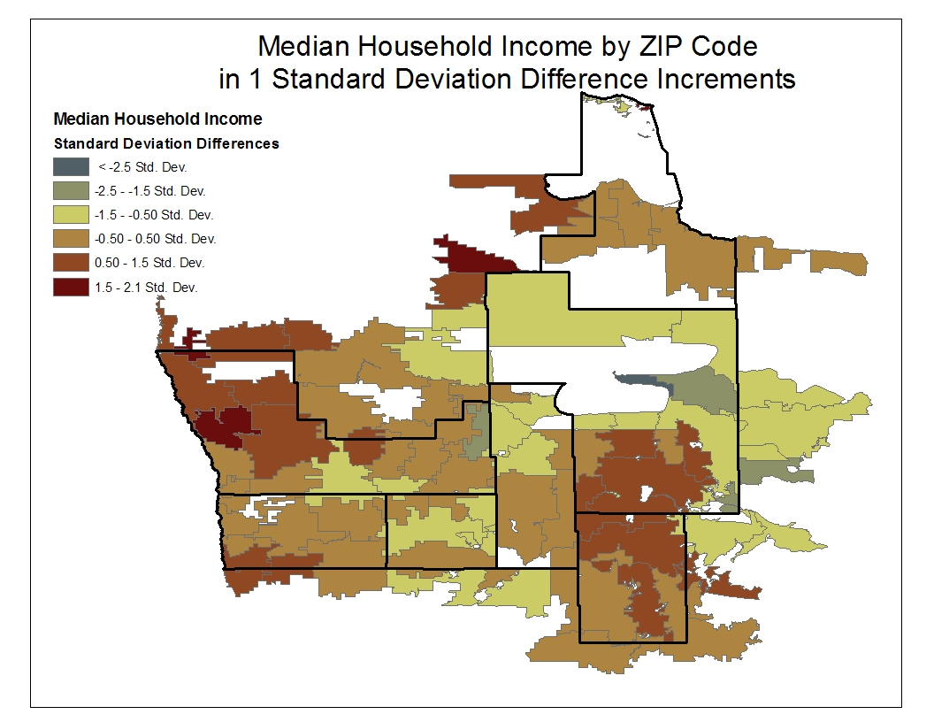

Figure 1

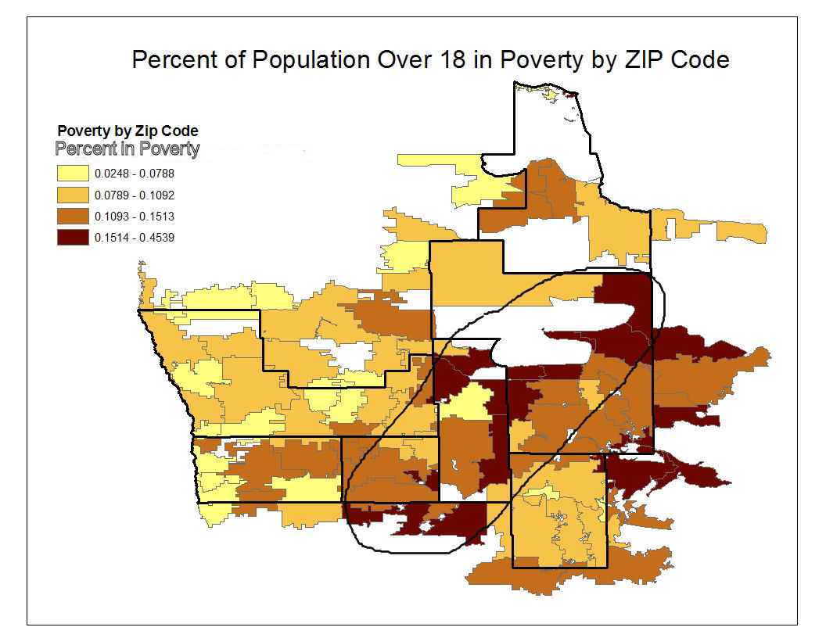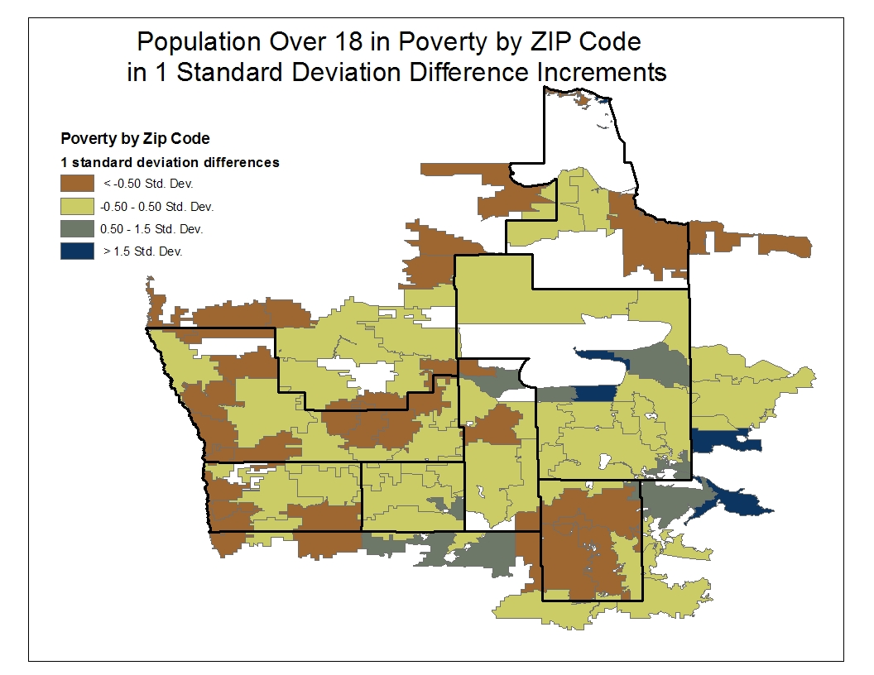

Figure 2

Figure 3

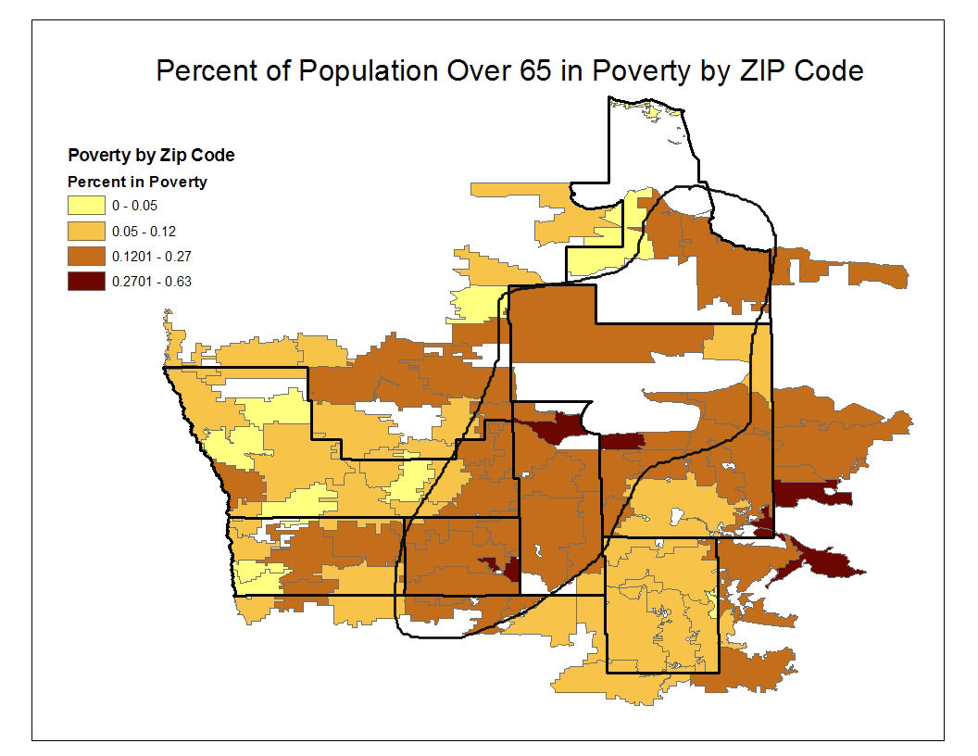

Figure 4

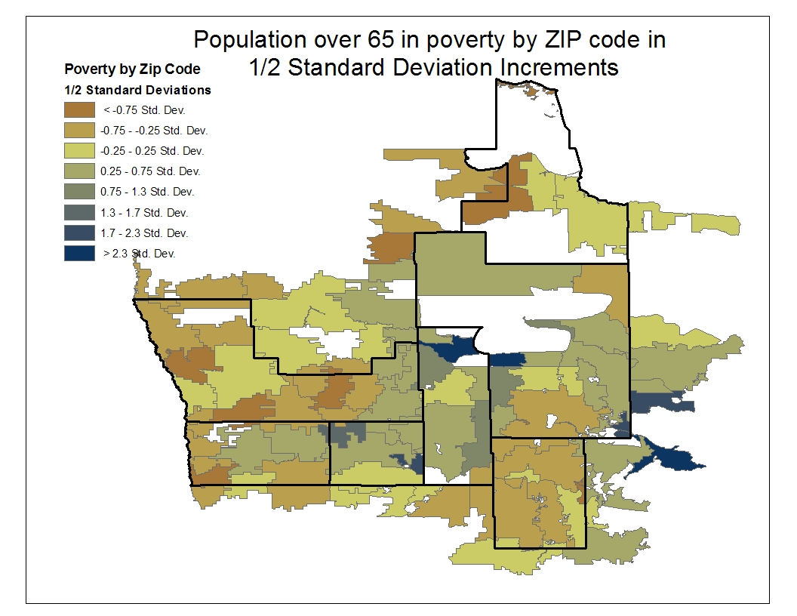

Figure 5

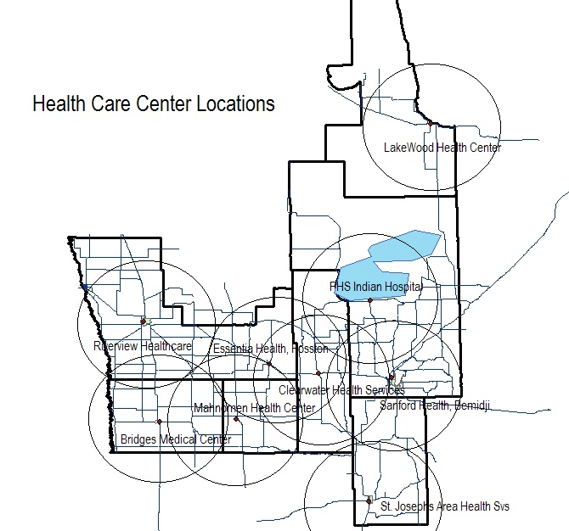

Figure 6

*Health Care Center Locations*

* Circles depict approximate 1 hour round trip drive time from centroid to perimeter and back.

*Primary Medical Care Physicians*

* Beltrami, Clearwater Mahnomen, Norman are Geographical Primary Care HPSAs and Hubbard, LOW and Polk are designated Low Income Primary Care HPSAs

*Dentists*

* All 7 counties are designated Low Income Dental HPSAs

*Mental Health Providers*

* All 7 counties are designated Geographical Mental Health HPSAs

**Behavioral Health Indicators**

**Methods-Minnesota Student Survey (MNSS)**

The Minnesota Student Survey (MSS) is a triennial survey of young people regarding a variety of risk and protective factors. The survey asks young people questions about their activities, opinions, behaviors and experiences. It includes questions on an array of priority health-risk behaviors including tobacco use, dietary habits, physical inactivity, substance abuse, school climate, violence and safety concerns, out-of-school activities, and connections to school, community and family.

The survey is administered in schools, alternative learning centers and juvenile correctional facilities across the state. The purpose of the survey has been to:

* Provide data for program planning and evaluation.
* Meet state and federal student survey requirements.
* Address relevant issues confronting students.
* Mark trends over time.
* Involve schools/other educational settings statewide and provide data for local use.

The 2013 MSS was administered in the first half of 2013 to public school students in grades 5, 8, 9 and 11, statewide. All public school districts in Minnesota were invited to participate. Of the 334 public operating districts, 280 agreed to participate (84 percent of public operating school districts).

The survey's methodology changed in 2013 in ways that make it challenging to compare some of the latest results to previous years. From 1992 to 2010, the state surveyed 6th, 9th and 12th graders. In 2013 that changed to 5th, 8th, 9th and 11th graders. Furthermore, a large number of questions were changed, omitted or added. To the extent that it was possible, variables on the 2013 MNSS were combined or parsed to extract data points that matched responses from previous iterations of the MNSS. ***The result was that 6 items of interest for SHIP/CTG longitudinal outcomes could be traced back through the 2007 administration.***

Public school student participation was voluntary and surveys were anonymous. Across the state, approximately 66 percent of fifth graders, 71 percent of eighth graders, 69 percent of ninth graders and 62 percent of eleventh graders participated in the 2013 MSS. Overall participation across the four grades was approximately 67 percent of total enrollment.

***In CTG/SHIP Region participation rates were: 83.0 percent of fifth graders, 80.1 percent of eighth graders, 84.9 percent of ninth graders and 71.1 percent of eleventh graders. Overall participation across the four grades was approximately 79.7% percent of total enrollment.***

All schools and districts that participated in the survey followed federal laws regarding parental notification as required by the Family Educational Rights and Privacy Act (FERPA) and the Protection of Pupil Rights Amendment (PPRA). PPRA requires that schools that participate in the survey notify parents of the survey administration, provide parents the opportunity to review the survey instrument, and allow parents to opt their child out of participating.

The description of behavioral health risks in youth for the CTG/SHIP Region was based on the culmination of 2007, 2010 and 2013 Minnesota Student Survey data. The summaries that follow provide information on students in grade 12 in 2007 and 2010 whereas in 2013 11th grade student data is presented. Data from older youth is used as they show by far the greatest prevalence of health risk behaviors compared to younger grades. Data on grade 11 and 12 students is deemed to be a relevant and succinct representation of county youth needs given the parameters of the CTG/SHIP intervention guidelines.

EvaluationGroup, LLC staff contacted the MN Student Survey administrators and obtained a copy of the raw dataset for further analysis which were used in this report. We are indebted to their generosity for permitting us use of this data in pursuit of improving health in Minnesotans.

**Methods –Behavioral Risk Factor Surveillance Survey (BRFSS)**

Behavioral Risk Factor Surveillance Data from multiple years was available for analysis and an overview is provided in the following figures and tables. While BRFSS findings allow for some measurement of adult population health, they are generally unreliable for populations in northwest Minnesota because they rely on a synthetic estimate based on population parameters based on individuals who do not reside in the area but rather are similar on demographic characteristics such as age and gender (See Appendix A for more details).

**Behaviors that Impact Health**

***Tobacco Use***

Results show that across all NC+3 counties, that smoking is higher than compared to the rest of the state. Slight decreases in adult smoking rates are suggested; however no differences between time frames rise to the level of statistical significance. Unfortunately, county level statistics on adult tobacco use do not exist for LOW County for either time period in the BRFSS data sets. According to telephone survey research conducted during the fall of 2013, approximately 25% of CTG/SHIP region residents are a current smoker, which is close to the average of 21% (the regional average for BRFSS 2006-12). Smokeless tobacco use in adults for this same survey was estimated at 21% (Limiting Tobacco Sales, 2014).

|  |  |  |  |  |
| --- | --- | --- | --- | --- |
| **Adult Smoking Rate Changes Over Time** | | | | |
| **County** | **Sample Size** | **%Smokers1 (95% CI)** | **Sample Size** | **%Smokers2 (95% CI)** |
| Mahnomen | 30 | nd | 77 | 35% (20-55) |
| Beltrami | 267 | 32% (25-40) | 583 | 30% (24-36) |
| Polk | 199 | 24% (18-32) | 315 | 24% (17-31) |
| Clearwater | 61 | nd | 164 | 20% (12-33) |
| Norman | 53 | nd | 125 | 19% (12-30) |
| Hubbard | 150 | 21% (13-32) | 260 | 17% (11-24) |
| Lake of the Woods | 30 | nd | nd | nd |
| State | 29,990 | 19 (18-19) | 47,025 | 16 (16-17) |
| 1BRFSS 2003-2009  2BRFSS 2006-2012 |  |  |  |  |

*Smoking During Pregnancy*

* Because tobacco use rates are generally higher in the region, smoking during pregnancy was examined. Data show that, the percentage of births to mothers who smoked in Mahnomen County was 42% higher than the state average.

|  |  |  |  |  |
| --- | --- | --- | --- | --- |
| **Births to Mothers Who Smoked During Pregnancy (Percent) Showing most recent 5 years; Show All Years** | | | | |
|  | **2007** | **2008** | **2009** | **2010** |
| Norman | 16% | 19% | 27% | 12% |
| Kittson | 7% | 13% | 11% | 12% |
| Polk | 15% | 15% | 14% | 14% |
| Clearwater | 23% | 22% | 25% | 16% |
| LOW | 11% | 17% | 14% | 23% |
| Hubbard | 23% | 18% | 21% | 25% |
| Beltrami | 24% | 26% | 28% | 31% |
| Mahnomen | 30% | 46% | 50% | 52% |
| Statewide | 10% | 10% | 10% | 10% |

*Youth Tobacco Use*

In a word, youth from the CTG/SHIP Region tend to use tobacco at far higher rates than those youth from the rest of the state.

* Use of any tobacco product over the past 30 days decreased substantially from 37.8% in 2007 to 23.9% in 2013. This represents a statistically significant drop in use across the region during this time frame.
  + Use of any tobacco product over the past 30 days (23.9%) is higher than compared to what is found across the rest of the state (state average 18.8%).



* Smokeless tobacco use appears to be declining slightly, moving from 16.0% in 2007 to 13.2% in 2013; and is down significantly from its peak in 2010 at 21.4%.
  + In general, over 90% of smokeless tobacco users tend to be male.
* Smokeless tobacco use in CTG/SHIP Region at 13.2% is nearly twice that found across the rest of the state 7.6%.



***Overweight/Obesity/Physical Activity:***

*Adult Weight Trends*

* Both the 2010 and 2014 County Health Rankings released by MDH, reveal that all of the counties in the CTG/SHIP Region likely have generally higher rates of obesity compared to the rest of the state. No statistically significant decreases or increases in obesity were evidenced between the BRFSS administration time periods in either the Region or statewide.

|  |  |  |  |  |
| --- | --- | --- | --- | --- |
| **Adult Obesity Rate Changes Over Time**  **Percent of adults that report a BMI of >=30** | | | | |
| **County** | | **% Obese1 (95% CI)** | | **% Obese2**  **(95% CI)** |
| Beltrami | | 29% (25-34) | | 28% (25-32) |
| Hubbard | | 27% (23-32) | | 29% (23-34) |
| Clearwater | | 28% (23-33) | | 30% (24-36) |
| Lake of the Woods | | 28% (23-34) | | 28% (22-35) |
| Norman | | 28% (23-33) | | 33% (27-40) |
| Mahnomen | | 28% (24-34) | | 31% (24-38) |
| Polk | | 28% (24-33) | | 30% (25-35) |
| **State** | | **26%** | | **26%** |
| 1BRFSS 2003-2009  2BRFSS 2006-2012 |  | |

*Youth Weight Trends*

* Increases are evidenced over time in the percentage of youth who are overweight, moving from 12.7% in 2007 to 16.6% in 2013. Further, the percentage of youth in the CTG/SHIP Region who are overweight is significantly higher (16.6%) compared to the statewide average (12.5%).



* A relatively steady percentage of obese youth in the CTG/SHIP Region is indicated, moving little from 11.9% in 2007 to 12.2% in 2013. Current rates of obesity in CTG/SHIP Region are significantly higher than the state average of 9.6%.



*Adult Physical Activity*

* The percent of adults aged 20 and over reporting no leisure-time physical activity increased an average of 6% from 2008 to 2010 and appears to be somewhat higher than the state average of 20%. Estimates suggest that approximately 31,947 residents may not be getting any form of meaningful exercise.

|  |  |  |
| --- | --- | --- |
| **Adult Physical Inactivity**  Percent of adults aged 20 and over reporting no leisure-time physical activity | | |
| **County** | **Physical Inactivity1**  **(95% CI)** | **Physical Inactivity2**  **(95% CI)** |
| Beltrami | 19% (16-23) | 24% (20-28) |
| Hubbard | 19% (15-23) | 24% (19-30) |
| Clearwater | 20% (15-25) | 26% (21-32) |
| Polk | 21% (17-27) | 27% (22-32) |
| Norman | 20% (15-25) | 29% (23-37) |
| Mahnomen | 23% (18-29) | 30% (24-37) |
| Lake of the Woods | 20% (15-26) | 24% (17-32) |
| Region Average | 20% | 26% |
| State | 18.9% | 20% |

1, 2 National Center for Chronic Disease Prevention and Health Promotion (2008 & 2010)

|  |  |  |
| --- | --- | --- |
| **Access to Exercise Opportunities**  The percent of adults aged 20 and over with adequate access to a park or recreation facility | | |
| **County** | **Percent of Population with ‘Access’** |
| Beltrami | 59% |
| Hubbard | 39% |
| Clearwater | 47% |
| Polk | 56% |
| Norman | 22% |
| Mahnomen | 27% |
| Lake of the Woods | 38% |
| State | 80% |

* Access to exercise opportunities measures the percentage of individuals in a county who live reasonably close to a location for physical activity. Locations for physical activity are defined as parks or recreational facilities. Parks include local, state, and national parks. Recreational facilities include businesses identified by the NAICS code 713940, and include a wide variety of facilities including gyms, community centers, YMCAs, dance studios and pools. Individuals who reside in a census block within a half mile of a park or within one mile of a recreational facility in urban areas (3 miles in rural areas) are considered to have adequate access to opportunities for physical activity.
* Limitations of data include: It does not accurately capture all the possible locations for physical activity within a county. One location for physical activity that is not included in this measure are sidewalks which serve as common locations for running or walking. Additionally, not all locations for physical activity are identified by their primary or secondary business code. For example, malls frequently have walking clubs and schools may have open gyms for community members. Second, although a county may contain a park or recreational facility there may still be barriers to using the facility for exercise. Cost can be a barrier as many facilities charge user fees and parks may charge entrance fees. Finally, the buffers used in this measure were chosen based on an estimation of a 5-10 minute walk to a park and a 5-10 minute drive to a recreational facility.

*Physical Activity in Youth*

* ‘No weekly activity’ has trended downward over time and is significantly lower in 2013 at 9.4% than it was in 2007 at 13.3. It is also currently lower than across the rest of the state (9.4% vs. 12.4%).
* Unfortunately, MNSS data do not exist for examining adequate physical activity levels over time as the metrics for measuring such activity have changed. In 2007 and 2010, adequate physical activity definitions included identifying 12th graders who reported ‘participating in either vigorous physical activity for 20 or more minutes per day on 3 or more days in the past 7 days or moderate physical activity for 30 or more minutes per day on 5 or more days in the past 7 days’. Current physical activity guidelines assessed 11th graders and asked: ‘During the last 7 days, on how many days were you physically active for a total of at least 60 minutes per day?’ Because of the lack of similarity in questioning, making comparisons between these data over time was not appropriate.



* The percentage of students meeting guidelines for physical activity requirements in the region appears to be significantly higher than state averages. The regional average percentage of students meeting guidelines for weekly physical activity is 19.3 (21.4-17.4; 95% confidence interval) and the state average is 16.6 (16.3 – 17.0; 95% confidence interval). Current U.S. Department of Health and Human Service guidelines recommend at least 60 minutes per day of either moderate or vigorous intensity aerobic physical activity and should include vigorous intensity physical activity at least 3 days a week. ([www.health.gov/paguidelines/guidelines/summary.aspx](http://www.health.gov/paguidelines/guidelines/summary.aspx))
* Data in these areas will continue to be examined during future CTG/SHIP efforts.



*Consumption of Fruits and Vegetables*

* Consumption of >5 servings of fresh fruits and vegetables per day has held generally constant at around 12-13.5% over time. Compared to the statewide average of 17.7% there appears to be room for re-focused efforts to improve fresh fruit and vegetable consumption opportunities for youth.



***Breastfeeding Rates***

* Minnesota children tend to be breastfed at a higher rate (82.5%) than children from the rest of the United States versus (74.6%) (Minnesota Department of Health, Minnesota Pregnancy Risk Assessment Monitoring System PRAMS, 2011).
* The breastfeeding initiation rate among WIC participants in Minnesota during 2010 was 74.5%.
* Polk County is 1 standard deviation below the Healthy People 2010 goal of 75%, whereas Clearwater, Mahnomen and Norman Counties are currently at greater than 2 standard deviations below that level.
* LOW, Beltrami and Hubbard Counties are at or above the Healthy People 2010 goal of 75% breastfeeding rates. For more information see <http://www.health.state.mn.us/divs/fh/wic/statistics/bffactsheet0312.pdf>

***Chronic Conditions***

*Adult Health Status*

* BRFSS data presented in the 2010 and 2014 County Health Rankings report produced by the Minnesota Department of Health reveals that across the state, 11% of respondents indicated Fair or Poor health at both time intervals. This is similar to the findings of residents across the region as depicted in the table below. With the possible exception of Clearwater County, the confidence intervals presented lie well within the statewide averages and so it is possible that no real differences exist on this issue. On the other hand, given the nature of the BRFSS data, further investigation into this issue to better detect differences may be warranted. Of positive note is that sample sizes in the later BRFSS study were substantially larger than in earlier iterations.

|  |  |  |  |  |
| --- | --- | --- | --- | --- |
| **Adult Poor or Fair health**  (percent of adults reporting fair or poor health-age adjusted) | | | | |
| **County** | **Sample Size** | **% Fair/Poor1 (95% CI)** | **Sample Size** | **% Fair/Poor2 (95% CI)** |
| Clearwater | 59 | 8% (4-17) | 163 | 17% (10-26) |
| Hubbard | nd | 10% (6-16) | 263 | 13% (8-19) |
| Norman | 53 | 11% (6-19) | 124 | 12% (7-18) |
| Beltrami | 267 | 14% (9-20) | 586 | 11% (8-15) |
| Polk | 200 | 13% (9-18) | 315 | 11% (9-15) |
| Lake of the Woods | 30 | nd | nd | nd |
| Mahnomen | 30 | nd | nd | nd |
| **State** |  | **11%** |  | **11%** |

1BRFSS 2003-2009

2BRFSS 2006-2012

* Similarly, all of the counties with data reported fewer than average (but within the confidence interval range) poor physical health days.

|  |  |  |  |  |
| --- | --- | --- | --- | --- |
| **Poor Physical Health Days**  (Average number of physically unhealthy days reported in the last 30 days –age adjusted) | | | | |
| **County** | **Sample Size** | **Physically Unhealthy Days1 (95% CI)** | **Sample Size** | **Physically Unhealthy Days2 (95% CI)** |
| Clearwater | 59 | 1.8% (0.6-3.1) | 160 | 3.6% (2.0-5.1) |
| Hubbard | nd | 2.7% (1.8-3.7) | 257 | 2.8% (1.8-3.7) |
| Beltrami | 264 | 2.9% (2.1-3.7) | 575 | 2.7% (2.0-3.3) |
| Polk | 197 | 2.6% (1.6-3.5) | 309 | 2.7% (1.9-3.4) |
| Mahnomen | 30 | nd | 76 | 2.3% (1.2-3.4) |
| Norman | 53 | 6.5% (1.5-11.6) | nd | nd |
| Lake of the Woods | 28 | nd | nd | nd |
| **State** |  | **3.1** |  | **2.8** |

1BRFSS 2003-2009

2BRFSS 2006-2012

***Diabetes***

* Synthetic Behavioral Risk Factor Surveillance Data (BRFSS) age adjusted estimates of diabetes within the region reveal that the prevalence of the disease may be elevated compared to the statewide average. Local public health staff believe strongly that the levels of diabetes within the region are higher than state averages.

|  |  |  |
| --- | --- | --- |
|  | **Age-Adjusted Estimates of the Percentage of Adults with Diagnosed Diabetes in Minnesota** | |
|  | % **Diagnosed Diabetic1**  **(95% CI)** | % **Diagnosed Diabetic2**  **(95% CI)** |
| Mahnomen | 10% (7-12) | 11% (8-14) |
| Norman | 9% (7-11) | 10% (8-13) |
| Clearwater | 8% (7-10) | 10% (7-13) |
| Hubbard | 8% (7-10) | 9% (7-12) |
| LOW | 9% (7-11) | 9% (6-12) |
| Polk | 8% (6-10) | 8% (7-11) |
| Beltrami | 7% (6-9) | 8% (7-10) |
| Statewide | 6 | 7 |

1Source: Centers for Disease Control and Prevention, Small Area Obesity Estimates (2008).

2Source: National Center for Chronic Disease Prevention and Health Promotion, Division of Diabetes Translation (2010).

***Cancer: Age-Adjusted Death Rates***

* Overall, cancer age adjusted death rates reveal that Norman, and Mahnomen Counties appear to have significantly higher overall cancer death rates than the rest of the state in the 2006-2010 time period.

|  |  |  |  |  |
| --- | --- | --- | --- | --- |
| **Cancer Age-Adjusted Death Rates** | | | | |
|  | **1991-1995** | **1996-2000** | **2001-2005** | **2006-2010** |
| **Norman** | 208.4 | 177.8 | 191.6 | 209.3 |
| **Mahnomen** | 204.1 | 230.0 | 195.0 | 203.4 |
| **Clearwater** | 206.8 | 201.7 | 187.2 | 177.6 |
| **Beltrami** | 201.1 | 176.1 | 185.1 | 171.7 |
| **Hubbard** | 203.3 | 202.6 | 159.1 | 167.3 |
| **Polk** | 216.5 | 211.3 | 171.9 | 165.5 |
| **LOW** | 183.1 | 198.1 | 179.8 | 164.2 |
| State | 196.3 | 191.6 | 178.2 | 169.6 |

Source: MN Department of Vital Statistics

***Heart Disease***

* According to Minnesota Vital Statistics, age adjusted death rates for heart disease reveals that historically all of the counties in the CTG/SHIP region have had a substantially higher rate of heart disease death rates year over year compared to the state on average.
* With the exception of Hubbard County, Age Adjusted Death Rates for Heart Disease in the region were higher than state averages from 2006-2010.
* Aggregated prevalence rates for heart disease at a county level do not exist. Rather, only death rates from heart disease. In order to better capture heart disease prevalence rates, it is recommended that counties consider conducting BRFSS-style population health surveys to more clearly ascertain the incidence and prevalence of this disease within the region.

|  |  |  |  |  |
| --- | --- | --- | --- | --- |
|  | **Heart Disease, Age Adjusted Death Rate** | | | |
|  | **1991-1995** | **1996-2000** | **2001-2005** | **2006-2010** |
|  |  |  |  |  |
| **Hubbard** | 261.4 | 235.4 | 167.6 | 119.9 |
| **Norman** | 297.7 | 208.5 | 178.0 | 136.1 |
| **Beltrami** | 240.8 | 212.4 | 172.8 | 143.7 |
| **Polk** | 267.8 | 216.2 | 162.9 | 148.6 |
| **Clearwater** | 204.2 | 256.3 | 239.2 | 166.2 |
| **Mahnomen** | 275.1 | 226.5 | 183.4 | 179.2 |
| **LOW** | 300.8 | 175.7 | 170.9 | 185.6 |
| **State** | 234.2 | 196.4 | 154.1 | 126.6 |

Green shaded cells indicate county number is higher than state average for that year

Source: <http://www.health.state.mn.us/divs/chs/Trends/index.html>

|  |
| --- |
|  |
| **% of diabetic Medicare enrollees that receive HbA1c screening** | |
|  | **2011**  **(most recent data)** |
| **Norman** | 92% |
| **Polk** | 87% |
| **Mahnomen** | 85% |
| **Hubbard** | 83% |
| **LOW** | 82% |
| **Beltrami** | 77% |
| **Clearwater** | 57% |
| **State** | 88% |
| County Health Profiles, 2014 | |

***Diabetic Screening***

Only Norman County is greater than the state average for the percentage of diabetic Medicare enrollees that receive HbA1c screenings. Clearwater County is the lowest at 57%.

***Mammography Screening***

Mahnomen and Clearwater Counties conduct mammographies in 55% and 57% of Medicare enrollees. This is lower than the state average of 68%. All other counties within the region are near or above the state average.

|  |
| --- |
|  |
| **% of female Medicare enrollees that receive mammography screening** | |
|  | **2011**  **(most recent data)** |
| **Beltrami** | 72% |
| **Norman** | 69% |
| **LOW** | 69% |
| **Hubbard** | 68% |
| **Polk** | 61% |
| **Clearwater** | 57% |
| **Mahnomen** | 55% |
| **State** | 68% |
| County Health Profiles, 2014 | |

**Qualitative Findings**

A massive aggregation of conceptual qualitative data was undertaken in the conceptualization and development of a grounded theory model of health concerns that impact the quality of life for the regions residents. A concept map was developed in order to assist readers in understanding the large volume of information provided. While the qualitative items identified in the concept map are incomplete in terms of exhausting phenomena contributing to the quality of life within the region, at this time it is a highlight of those recurring items viewed by participants as most influential.

Data were derived from the following qualitative studies:

***1) Statewide Health Improvement Program 2010 Interview Notes Analysis***

* A review analysis of 24 interviews conducted by SHIP 1.0 staff in the fall of 2010 was conducted.

***2) Norman, Polk, Mahnomen: Community Themes and Strengths Discussion Groups***

* Over 45 individuals participated in focus groups and individual conversations with public health staff held throughout the summer of 2013 in Polk, Norman and Mahnomen Counties. Participants were asked to think broadly about the different recurring needs and concerns of clients and the general population served by them and their organizations as well as what they believed were the 2-3 most important issues that should be addressed in order to help further improve the quality of life for people in their community (county)?”

***3) Quin Community Health Services: Community Themes and Strengths Discussion Groups***

* Over 20 NWCAC community forum meetings and individual interviews occurred across the five-county region and involved over 100 individuals. A similar series of questions was generally asked of all participants and was patterned closely to the process implemented in Norman, Polk and Mahnomen Counties.

***4) Northern Dental Access Center: Key Informant Interviews***

* As part of Northern Dental Access Centers community health needs assessment, they conducted more than 140 key informant interviews and their target audience was surveyed.

***Variance (Concept) Map of CTG/SHIP Region Top Concerns Impacting Quality of Life***

DEMOGRAPHIC TRENDS

* Aging population
* Youth out-migration
* Drugs
* Tobacco
* Alcohol
* Cancer
* Heart Disease
* Teen Pregnancy
* Suicide

Mental Illness

Housing

Healthcare

**Families/Children & Elderly**

Jobs/Employment

Low Income

Obesity

Transportation

* Distance to Services
* Inappropriate/Lack of Access -72 hour holds.
* Prison population mental health issues
* Stigma
* Cultural needs
* Elderly-Depression
* Mental health concerns at home, schools and work
* Need more psychiatrists, and child psych.
* Behavioral health Medicaid reimbursements are low, results in long wait times
* Many people undiagnosed/untreated
* Low physical activity
* Poor nutrition choices/options
* Access/transportation to healthy foods
* Low nutrition education
* Food shelves giving out unhealthy foods
* Affordability
* Availability
* Lack of Assisted living facilities
* Health insurance and health care costs
* Glenmore closure. No detox center
* End of life care costs
* High Deductibles
* Need for services not covered
* Medicaid enrollment complexity
* Preventive care visits a luxury
* Limited dental svs. Esp. for low income
* Overall complexity of healthcare system
* Generational Poverty
* Poor Financial education
* Reduced work hours
* Addictions
* Low education
* Challenge of self-advocacy for healthcare
* Better pay to help afford daycare
* Availability of good paying jobs
* Better accommodations for illness, personal/family appointments
* Travel to medical appointments
* No evening/weekend routes
* Stigma of riding the bus
* Expensive if a family has many children
* Long distance to care esp. if no reliable vehicle.
* Bad winter roads
* Taxi/medi-van fare expensive

Youth and Adult Community Rec Opportunities

* Community safety
* Need more trails, dog parks, etc.
* Few places for families to gather
* Better marketing of family events
* Need to increase parent supports
* Lack of affordable and quality daycare
* Lack of positive role models
* Increase in single parent families
* Need more sit-down meals

Schools

* Low education quality? Poor curriculum
* Referendums
* Not cooperating enough with local colleges
* Should take out pop machines in schools

Trying to pay off large medical bills

**Ideas, Suggestions and Recommendations**

**Based on the Data Reviewed and the Current CTG Workplan**

**(Working Document)**

**Physical Activity**

**CTG Workplan Item:** *increase the number of residents in communities with access to physical activity opportunities from an unknown baseline (to be determined) to 15,000 (based on 3 cities with average population of 5,000 residents/city).*

**CTG Workplan Item:** *increase the number of students in rural schools with access to walking and biking to school in project area from an unknown baseline (to be determined) to 900 (based on 2 schools with average of 450 students/school).*

**CTG Workplan Item:** *increase the number of students in rural schools that have access to active school day opportunities (includes active classrooms, active recess, and school physical education) in project area from an unknown baseline (to be determined) to 900 (based on 2 schools with 450 students/school).*

* Physical education programs provide much of the physical activity non-athletically involved children get during a school day, especially in winter months.
  + PE classes have become optional in some schools and grades. It is not always required every day. Which schools differ on continuums of physical activity during the day? Are some schools more ‘physically active’ than other schools? Document how we know this.
* Identify specific target segments you are trying to reach (See Appendix B)
  + Consider working with DNR to help promote physical activity outdoors. Collaborate to promote take a kid fishing day or youth deer hunting.
  + In what ways can ATV/Snowmobile use be incorporated to instill outdoor recreation in youth?
* Can schools rent out bikes to students? Can local businesses donate bikes to schools?
* Access to physical activity may be in large part limited due to transportation to opportunity locations. In what ways can transportation to recreation opportunities be overcome?

**Nutrition**

**CTG Workplan Item:** *increase the number of students in schools with increased access to healthier foods and beverages from an unknown baseline (to be determined) to 5,000 (based on 10 schools with 500 students/school).*

* As smoking and income are linked, so is eating and income. Lower income families tend to eat unhealthier. Where do low income people eat in communities across the region? Focus of marketing efforts can occur around or near or in those areas.
* There are multiple interventions on the tobacco front. There are a number of activities on the nutrition front, but not as coordinated as tobacco. In what ways are the efforts of other organizations aligned with CTG regarding healthy eating that have not yet been explored?
* Kids have to eat. They don’t have to smoke.
* School concession stands still are largely unhealthy. Consider promoting policies raising the price of unhealthy foods by a negligible amount (5 cents) to help subsidize healthier options such as fruits or yogurts.
* Work closely with Nevis schools to develop training/learning materials to share how they made their school lunches healthier and less costly.
* Consider tracking the redemption of free fruit/vegetable WIC vouchers. Track how many go unused monthly. Anecdotal evidence suggests that within the region it is the most unused WIC voucher.
* Better definitions of what access to healthy foods is needs to be enumerated.

**Tobacco Use**

**CTG Workplan Item:** *increase from an unknown baseline (to be determined) to 17,500 the number of individuals living in communities improving access to smoke-free rental housing.*

**CTG Workplan Item:** *increase the number of youth from an unknown baseline (to be determined) to 6,575 living in communities that protect minors from exposure to tobacco products in retail outlets.*

**CTG Workplan Item:** *increase the number of youth from an unknown baseline (to be determined) to 6,575 living in communities that improve access to smoke-free foster care.*

**Program Evaluation and Clinical Work**

**CTG Workplan Item:** *Increase the number of CTG evaluations plans, in coordination with MDH, from 0 to 1 and refine it.*

**CTG Workplan Item:** *Support MDH to increase from 0 to 1 the number of plans in place with Minnesota Community Measurement for a new prevention measure to capture health outcomes population-wide and state-wide.*

**CTG Workplan Item:** *Increase the number of persons with high blood pressure and high cholesterol levels in rural regions that are referred to community resources to support healthy eating, physical activity, tobacco cessation, and chronic disease management from an unknown baseline (to be determined) to 500 (based on 500 patients/clinic).*

***Action Options:*** Consider finding new and alternative ways to gather important data because relying on the MNSS or other big survey(s) for data that matter longitudinally is risky due to changes in surveys over longer time periods.

* 1. Conduct regional Behavioral Risk Factor Surveillance Survey (BRFSS) A very limited amount of data currently exists and most of it is synthetic estimation. Currently, scant information exists regarding questions surrounding the extent to which individuals have taken part in screenings of multiple types, sodium intake, blood pressure, physician conversations pertaining to smoking cessation and the extent to which people have to drive to get services.
     1. It is advisable to administer surveys similar to the BRFSS questionnaires on the local / regional levels that will allow health officials to conduct better assessments of community needs, which would help shape and implement health policy measures to improve health status of local Minnesotans.
     2. Continue to keep in close communication with CTG staff at MDH to
  2. Observational studies
     1. Seatbelt use observations on state, county and township roads.
     2. Obesity/overweight observations in community settings.
     3. Recreational parks and activities use patterns (e.g., swimming pool use, park use, community education needs/wants).
     4. Others
  3. Assemble a regional data repository that is reviewed and updated annually with indicators agreed upon by stakeholders. This collaborative effort would involve not only data acquisition but also interpretation of existing data, identification of data weaknesses, ongoing recommendations for bolstering data quality and meeting data tracking requirements across a variety of activities.
  4. Partners in the regional data collaborative could include among others:

Northwest Regional Development Commission

Headwaters Regional Development Commission

Northwest Minnesota Council of Collaboratives

Northwest Minnesota Foundation

Northwest Service Cooperative

Bremer Foundation

County, township, & city governments

Law enforcement

Schools

Public Health

Healthcare centers

University collaborators

EvaluationGroup, LLC

Others…

* 1. There should be a primary point of contact/aggregation point for evaluations results, summary reports, archival data etc.
     1. Data-sharing agreements in place
  2. Take advantage of future dollars available for community/county health assessments by developing future collaborative assessment plans now.
     + - 1. Consider using mixed modes of administration for maximum response rate.

**CTG Workplan Item:** *Increase the number of CTG communication plans, in coordination with MDH, from 0 to 1 and refine it.*

***Action Options:*** Explore with greater specificity Target Market Segmentation

* + 1. Identify and review methods for reaching distinct market segment groups served by regional health providers. Stratifications by socio-economic status and consumer market preferences could be useful
    2. Claritas/PRISM market data provides a template for such activities.
    3. What does MDH know about target marketing/segmentation relative to CTG/SHIP activities?
    4. How can CTG/SHIP incorporate expertise on market segmentation from Leslie Staker at Rumor Has It?
    5. Hold conversations with CLT members/key stakeholders about who our target audience(s) are and what we know about their psychological and geographical makeup. Identify what we know and state it explicitly.
    6. Possibly conduct focus groups in future efforts to identify market segments/psychological characteristics of the target markets that public health efforts are trying to reach.

1. What are the top regional health priorities?
   1. Home in on top issues, do a good job tracking those and then scale up from there?
      * 1. Tobacco
        2. Obesity/Overweight
        3. Heart disease
        4. Alcohol use/alcohol related crashes
        5. Underserved medically

APPENDIX A: BRFSS METHODOLOGY

The Behavioral Risk Factor Surveillance System (BRFSS) is a state-based system of health surveys that collects information on health risk behaviors, preventive health practices, and health care access primarily related to chronic disease and injury. The BRFSS questionnaire is designed by a working group of state coordinators and CDC staff and is administered annually through a random-digit-dialed telephone survey of the U.S. adult (18 and over) non-institutionalized population. The survey includes core questions that are asked by all participating states in a given year, optional modules that a state may use in their survey and state-specific questions. Furthermore core modules consist of fixed-core questions and a rotating core.

While fixed core BRFSS items include questions about *cigarette smoking*, *leisure time exercise i*n the past 30 days as well as height and weight information that allows calculation of indices of obesity such as *body mass index (BMI),* some rotating core modules are only used biannually and include specific questions about weekly levels of *moderate and vigorous physical activity,* as well as *daily consumption of fruits and vegetables*.

Optional BRFSS modules relevant to the present project include questions regarding smokeless tobacco use and smoking policy. Since 2001 the smokeless tobacco module has been expanded to include other tobacco products such as cigar and pipe use. Although in the publicly accessible CDC databases for the past 12 years this module was offered several times including the 2008 BRFSS questionnaire, the state of Minnesota did not use it in any of the years of its availability. However, the 2004 BRFSS administration in Minnesota did include another optional module on secondhand smoke policy.

**Methodology used on BRFSS in this Report**

This report provides the most recent available state and county data on important behavioral risks including physical activity levels, consumption of fruits and vegetables, excessive alcohol consumption, tobacco use, exposure to second hand smoke, preventive cancer screenings, overweight and obesity levels. The report also provides prevalence rates for debilitating chronic conditions and life threatening events such as heart disease, diabetes and stroke.

All state and county data have been extracted from the Behavioral Risk Factor Surveillance Survey (BRFSS) database. Specifically, indices of tobacco use, excessive alcohol consumption, overweight and obesity, chronic conditions and cancer screenings were obtained from the 2010 and 2012 BRFSS database.

Furthermore out of 7 counties of interest (Hubbard, Beltrami, Polk, LOW, Clearwater, Mahnomen, and Norman) BRFSS data was only available for the first three. No raw data was available for any of the other counties. While the number of individuals surveyed in the remaining counties in the most representative year of 2010 were still fairly low (63 participants in Hubbard County, 117 participants in Beltrami County and 76 individuals in Polk County), prevalence estimates for specific risks and conditions in these counties were further adjusted using combined weights derived by the Centers for Disease Control (CDC) during national BRFSS administration.

Specifically the final weights used in statistical estimation on the state and county levels take into consideration the Stratum weight (number of records in a stratum divided by the number of records selected), Raw weighting factor (number of adults in the household divided by the imputed number of phones), and the Post-stratification weight (Population estimate for race/gender/age categories divided by the weighted sample frequency by race/gender/age). Adjustment by the final weight is thus thought to render more accurate estimates of population statistics which are presented in this report with 95% confidence (a range of values that is 95% likely to contain the true population value).

APPENDIX B: IDEAS FOR TARGET MARKET SEGMENTATION/IDENTIFICATION WITHIN REGION

PRISM Market Segmentation-Claritas

* 20 Fast Track Families
* 28 Traditional Times
* 33 Big Sky Families (could use this segment to market physical activity ideals to other segments)
* 37 Mayberry-ville
* 38 Simple Pleasures
* 42 Red, Whites & Blues
* 43 Heartlanders
* 45 Blue Highways
* 50 Kid Country
* 51 Shotguns & Pickups
* 55 Golden Ponds
* 56 Crossroads Villagers
* 57 Old Milltowns
* 58 Back Country Folks

**20   Fast-Track Families**

Upscale Middle Age w/ Kids

With their upscale incomes, numerous children, and spacious homes, Fast-Track Families are in their prime acquisition years. These middle-aged parents have the disposable income and educated sensibility to want the best for their children. They buy the latest technology with impunity: new computers, DVD players, home theater systems, and video games. They take advantage of their rustic locales by camping, boating, and fishing.

*Social Group:* Landed Gentry

*Life Stage Group:* Young Accumulators

**2011 Statistics:**

*US Households*: 1,861,697 (1.59%)

*Median HH Income*: $74,201

**Lifestyle Traits:**

· Order from buy.com

· Business travel by airplane

· Read American Hunter

· Watch Country Music Television

· Chevrolet Suburban Flex Fuel

**Demographics Traits:**

*Urbanicity*: Town/Rural

*Income*: Upscale

*Income Producing Assets*: High

*Age Ranges*: 35-54

*Presence of Kids:* HH w/ Kids

*Homeownership*: Mostly Owners

*Employment Levels:* Management

*Education Levels*: College Graduate

*Ethnic Diversity*: White

**28   Traditional Times**

Upper-Mid Older w/o Kids

Traditional Times is the kind of lifestyle where small-town couples nearing retirement are beginning to enjoy their first empty-nest years. Typically in their fifties and sixties, these upper-middle-class Americans pursue a kind of granola-and-grits lifestyle. On their coffee tables are magazines with titles like Country Living and Country Home. But they're big travelers, especially in recreational vehicles and campers.

*Social Group:* Country Comfort

*Life Stage Group:* Conservative Classics

**2011 Statistics:**

*US Households:*3,300,488 (2.82%)

*Median HH Income*: $55,175

**Lifestyle Traits:**

· Order from Gevalia Kaffe

· Domestic travel by motor home

· Read AARP The Magazine

· Watch Antiques Roadshow

· Chevrolet Impala Flex Fuel

**Demographics Traits:**

*Urbanicity*: Town/Rural

*Income*: Upper-Mid

*Income Producing Assets:* High

*Age Ranges:* 55+

*Presence of Kids:* HH w/o Kids

*Homeownership:* Homeowners

*Employment Levels:* White Collar, Mix

*Education Levels:* Some College

*Ethnic Diversity:* White

**33   Big Sky Families**

Upper-Mid Middle Age w/ Kids

Scattered in placid towns across the American heartland, Big Sky Families is a segment of middle age rural families who have turned high school educations and blue-collar jobs into busy, upper-middle-class lifestyles. Residents enjoy baseball, basketball, and volleyball, as well as fishing, hunting, and horseback riding. To entertain their sprawling families, they buy virtually every piece of sporting equipment on the market.

*Social Group:* Country Comfort

*Stage Life Group:* Mainstream Families

**2011 Statistics:**

*US Households:*2,130,960 (1.82%)

*Median HH Income:* $55,553

**Lifestyle Traits:**

· Order from eBay.com

· Attend high school sports

· Read Field & Stream

· Watch X Games

· Chevrolet Silverado Diesel

**Demographics Traits:**

*Urbanicity:* Rural

*Income:* Upper-Mid

*Income Producing Assets:* Moderate

*Age Ranges:* <55

*Presence of Kids:* HH w/ Kids

*Homeownership:* Mostly Owners

*Employment Levels:* BC, Service, Mix

*Education Levels:* Some College

*Ethnic Diversity:* White

**37   Mayberry-ville**

Upper-Mid Older w/o Kids

Like the old Andy Griffith Show set in a quaint picturesque berg, Mayberry-ville harks back to an old-fashioned way of life. In these small towns, upper-middle-class couples like to fish and hunt during the day, and stay home and watch TV at night. With lucrative blue-collar jobs and moderately priced housing, residents use their discretionary cash to purchase boats, campers, motorcycles, and pickup trucks.

*Social Group:* Country Comfort

*Life Stage Group:* Midlife Success

**2011 Statistics:**

*US Households:*2,756,347 (2.36%)

*Median HH Income:*$53,744

**Lifestyle Traits**

· Shop at Sherwin-Williams

· Go hunting with a gun

· Read Bassmaster

· Watch Daytona 500

· GMC Sierra Diesel

**Demographics Traits:**

*Urbanicity:* Town/Rural

*Income:* Upper-Mid

*Income Producing Assets*: Above Avg.

*Age Ranges:* 45-64

*Presence of Kids:* HH w/o Kids

*Homeownership:* Mostly Owners

*Employment Levels:* BC, Service, Mix

*Education Levels:* High School Grad

*Ethnic Diversity:* White

**38   Simple Pleasures**

Lower-Mid Mature w/o Kids

With many of its residents over 65 years old, Simple Pleasures is mostly a retirement lifestyle: a neighborhood of lower-middle-class singles and couples living in modestly priced homes. Many are high school-educated seniors who held blue-collar jobs before their retirement. And a disproportionate number served in the military, so many residents are members of veterans clubs.

*Social Group:* Middle America

*Life Stage Group:* Cautious Couples

**2011 Statistics:**

*US Households*: 2,754,587 (2.36%)

*Median HH Income*: $43,257

**Lifestyle Traits:**

· Shop at True Value

· Belong to a fraternal order

· Read fraternal magazines

· Watch Wheel of Fortune

· Ford Taurus

**Demographics Traits:**

*Urbanicity:* Town/Rural

*Income:* Lower-Mid

*Income Producing Assets:* Above Avg.

*Age Ranges*: 65+

*Presence of Kids:* HH w/o Kids

*Homeownership:* Homeowners

*Employment Levels*: Mostly Retired

*Education Levels:* High School Grad

*Ethnic Diversity:*  White

**45   Blue Highways**

Lower-Mid Older w/o Kids

On maps, blue highways are often two-lane roads that wind through remote stretches of the American landscape. Among lifestyles, Blue Highways is the standout for lower-middle-class residents who live in isolated towns and farmsteads. Here, Boomer men like to hunt and fish; the women enjoy sewing and crafts, and everyone looks forward to going out to a country music concert.

*Social Group* : Middle America

*Life Stage Group*: Striving Singles

**2011 Statistics:**

*US Households*: 1,809,961 (1.55%)

*Median HH Income*: $43,023

**Lifestyle Traits :**

· Shop at Wal-Mart

· Own satellite dish

· Read Guns & Ammo

· Watch auto racing

· Chevrolet Colorado

**Demographics Traits:**

*Urbanicity:* Rural

*Income:* Lower-Mid

*Income Producing Assets:* Moderate

*Age Ranges*: 45-64

*Presence of Kids:* HH w/o Kids

*Homeownership:* Homeowners

*Employment Levels*: BC, Service, Mix

*Education Levels:* High School Grad

*Ethnic Diversity:* White

**50 Kid Country, USA**

Lower-Mid Younger w/ Kids

Widely scattered throughout the nation's heartland, Kid Country, USA is a segment dominated by large families living in small towns. Predominantly white, with an above-average concentration of Hispanics, these young, working-class households include homeowners, renters, and military personnel living in base housing; about 16 percent of residents own mobile homes.

*Social Group:* Middle America

*Life stage Group:* Mainstream Families

**2011 Statistics:**

*US Households:*1,481,771 (1.27%)

*Median HH Income*: $42,166

**Lifestyle Traits**

· Order from oldnavy.com

· Buy infant toys

· Read Fit Pregnancy

· Watch Nick at Nite

· Nissan Titan Flex Fuel

**Demographics Traits:**

*Urbanicity*: Town

I*ncome*: Lower-Mid

*Income Producing Assets*: Low

*Age Ranges*: 25-44

*Presence of Kids*: HH w/ Kids

*Homeownership*: Mix, Owners

*Employment Levels*: WC, Service, Mix

*Education Levels*: High School Grad

**51   Shotguns & Pickups**

Lower-Mid Younger w/ Kids

The segment known as Shotguns & Pickups came by its moniker honestly: it scores near the top of all lifestyles for owning hunting rifles and pickup trucks. These Americans tend to be young, working-class couples with large families, living in small homes and manufactured housing. Nearly a third of residents live in mobile homes, more than anywhere else in the nation.

*Social Group:* Middle America

*Stage Life Group:*  Mainstream Families

**2011 Statistics:**

*US Households:*1,873,167 (1.60%)

*Median HH Income:*$41,859

**Lifestyle Traits:**

· Shop at Sears Hardware

· Go camping

· Read North American Hunter

· Watch Outdoor Channel

· Ford F-Series

**Demographics Traits:**

*Urbanicity*: Rural

*Income:* Lower-Mid

*Income Producing Assets:* Low

*Age Ranges:* 25-44

*Presence of Kids:* HH w/ Kids

*Homeownership:* Mostly Owners

*Employment Levels:* BC, Service, Mix

*Education Levels:* High School Grad

*Ethnic Diversity*: White, Black, Mix

**55   Golden Ponds**

Downscale Mature w/o Kids

Golden Ponds is mostly a retirement lifestyle, dominated by downscale singles and couples over 65 years old. Found in small bucolic towns around the country, these high school-educated seniors live in small apartments on less than $35,000 a year; one in five resides in a nursing home. For these elderly residents, daily life is often a succession of sedentary activities such as reading, watching TV, playing bingo, and doing craft projects.

*Social Group:* Rustic Living

*Stage Life Group:* Sustaining Seniors

**2011 Statistics:**

*US Households:*1,985,453 (1.70%)

*Median HH Income:* $31,657

**Lifestyle Traits**

· In-home vitamin purchase

· Order garden supplies by phone

· Read American Legion Magazine

· Watch The Price is Right

· Mercury Sable

**Demographics Traits:**

*Urbanicity:* Town/Rural

*Income:* Downscale

*Income Producing Assets:* Below Avg.

*Age Ranges:* 65+

*Presence of Kids:* HH w/o Kids

*Homeownership:* Mostly Owners

*Employment Levels:* Mostly Retired

*Education Levels:* Some High School

*Ethnic Diversity:* White

**56   Crossroads Villagers**

Downscale Older w/o Kids

With a population of white-collar couples and families, Crossroads Villagers is a classic rural lifestyle. Residents are high school-educated, with downscale incomes and modest housing; one-quarter live in mobile homes. And there's an air of self-reliance in these households as Crossroads Villagers help put food on the table through fishing, gardening, and hunting.

*Social Group:* Rustic Living

*Life Stage Group:* Striving Singles

**2011 Statistics:**

*US Households:*2,466,414 (2.11%)

*Median HH Income:*$32,084

**Lifestyle Traits:**

· Shop at Wal-Mart Pharmacy

· Own a motor home

· Read Motorcyclist

· Watch The Jerry Springer Show

· Chevrolet Aveo

**Demographics Traits:**

*Urbanicity:* Town/Rural

*Income:* Downscale

*Income Producing Assets:* Low

Ag*e Ranges:* 45-64

*Presence of Kids*: HH w/o Kids

*Homeownership:* Homeowners

*Employment Levels:* WC, Service, Mix

*Education Levels:* High School Grad

*Ethnic Diversity:* White, Black, Mix

**57   Old Milltowns**

Downscale Mature Mostly w/o Kids

America's once-thriving mining and manufacturing towns have aged--as have the residents in Old Milltowns communities. Today, the majority of residents are retired singles and couples, living on downscale incomes in pre-1960 homes and apartments. For leisure, they enjoy gardening, sewing, socializing at veterans clubs, or eating out at casual restaurants.

*Social Group*: Rustic Living

*Life stage Group*: Sustaining Seniors

**2011 Statistics:**

*US Households*: 1,845,943 (1.58%)

*Median HH Income*: $30,608

**Lifestyle Traits**

· Order from Home Shopping Network

· Do needlepoint

· Real Good Housekeeping

· Watch As the World Turns

· GMC Canyon

**Demographics Traits:**

*Urbanicity*: Town

*Income*: Downscale

*Income Producing Assets*: Below Avg.

*Age Ranges*: 65+

*Presence of Kids*: Mostly w/o Kids

*Homeownership*: Mostly Owners

*Employment Levels*: Mostly Retired

*Education Levels*: High School Grad

*Ethnic Diversity*: White, Black, Mix

**58   Back Country Folks**

Downscale Mature Mostly w/o Kids

Strewn among remote farm communities across the nation, Back Country Folks are a long way away from economic paradise. The residents tend to be poor, over 65 years old, and living in older, modest-sized homes and manufactured housing. Typically, life in this segment is a throwback to an earlier era when farming dominated the American landscape.

*Social Group:* Rustic Living

*Life Stage Group:* Sustaining Seniors

**2011 Statistics:**

*US Households*: 2,658,532 (2.27%)

*Median HH Income*: $32,207

**Lifestyle Traits:**

· Order from Publishers Clearing House

· Belong to church board

· Read Hunting

· Watch Soap net

· Ford Ranger

**Demographics Traits:**

*Urbanicity:* Rural

*Income:* Downscale

*Income Producing Assets:* Below Avg.

*Age Ranges:* 65+

*Presence of Kids:* Mostly w/o Kids

*Homeownership:* Mostly Owners

*Employment Levels:* Mostly Retired

*Education Levels:* Some High School

*Ethnic Diversity:* White, Black, Mix

***Appendix C: Concept/Variance Map Categories***

*What do you believe are the 2-3 most important issues that should be addressed in order to help further improve the quality of life for people in our community (county)?*

**Mental Health/Illness**

Mental Health concerns were discussed at length across most all meetings. Participants indicated that distance to services, inappropriate service utilization, problems at home, school, and work were problems. Additionally, county jails were believed to be housing large populations of the regions mentally ill.

*Distance to Services*

* Access to closer mental health facilities -distances are far to travel to get help

*Inappropriate/Lack of Access to Services*

* Access and cost of mental health services can be prohibitive.
* The first six months of 2012 there were 47 incidences of needing 72 hour holds. Many were new patients.
  + Because of new state mandates, regional treatment centers are no longer available and smaller, community centers are to take the place but communities don’t want them and therefore a reduction in # of beds. Treatment centers that take behavioral problems are especially difficult to replace.
  + When people seek out mental health treatment either at ER or elsewhere it’s important for them to have a positive experience so that they will continue to seek treatment. Bad experience – they’re done.
* Lack of access to mental health services, waited over 4 months to have a student seen who should have been in immediately. No resources for ongoing appointments or treatment follow up because of the lack of mental health services locally and even regionally.
* Need quality, experienced outpatient services, especially those serving adolescence patients for intensive services.
* Mental health issues in both parents and students. Many undiagnosed and untreated. Households living in a constant state of turmoil
* People are struggling in silence, seems like they can get to the right resources and into professionals if they need to.

*Prison Population*

* Most if not all jailed locally are on meds for mental illness, many end up in jail because they lack access to their meds or aren’t taking them when they have them.

***“Mental health issues are a quiet disease/affliction. People aren’t on the prayer list. It’s an underlying reason for outward problems.”***

* Some participants believed that upwards of 90% of inmates have a mental illness.

*Mental Health Concerns at Home*

* Undiagnosed mental illness among parents. Single moms caring for young children in the home are depressed but don’t seek help. Leads to other problems such of nutrition, behavior, sleep habits, etc. of their children because they are allowed to do what they want. Social Media becomes their outlet and they don’t have any Social connectedness outside of Facebook, texting, etc. Children don’t learn how to handle social situations because they don’t leave home.

*Mental Health Concerns in Schools*

* Mental illness occurring among children.
  + We are seeing severely, challenging behaviors in the classroom that have not been seen before and teachers not equipped to deal with them.
  + The number of children with behavioral problems has increased significantly in recent years. Factors that may be causing these include stressful home environments, lack of proper nutrition, poor sleep habits, lack of parenting skills by caregiver, parental self-esteem, and access to violent video games, TV and media.
  + More undiagnosed depression among students

*Mental Health Concerns at Work*

* Mental health issues are very prevalent as it causes a lot of absenteeism and terminations. We have the resources of Village EAP and therefore a referral source.
  + Depression seems to be a big problem and much of it is untreated. Employees don’t realize they are depressed; view it as a condition if someone is “suicidal”.

**Obesity**

Obesity was mentioned at each meeting/interview as one of the major health concerns of the region. Attendees advocated for education starting very young regarding diabetes, nutrition, caloric needs and exercise.

*Physical Activity*

***“Obesity is a huge issue for our region. We need to change our mind set about eating, to eat to live not live to eat. I know that is very hard to do. But, I really think we need to work on our children starting from a very early age”***

* More biking/walking trails needed
* Kids don’t get enough exercise, there isn’t anywhere for them to exercise.

*Nutrition*

* Eating habits
* School lunch program has seen students eating fruits and vegetables but the kids are hungry because there is not enough protein or carbohydrates in their diets
* Reduced work week has caused lack of nutritious food at home because it is too expensive
* Need to have healthier eating for students at home. People have basic knowledge but they are too tired or it is too expensive.
* Too many obese and unhealthy children and parents that don't do anything to make changes.

*Obesity in General*

* Feel childhood obesity is more prevalent in minority groups in the Warroad area
* Obesity is a problem from K- 12.
* Obesity/overweight preschoolers (3-5year olds). 17% of those served are obese and 22% are overweight(lack of proper nutrition at home) (in head start)

**Housing**

Availability of appropriate housing for people at all age ranges, levels of income, and degrees of physical ability were of great concern to participants. Shortages of affordable housing were reported to exist.

*Affordability/Availability of Housing*

* Affordable housing
  + Housing (good, clean, affordable)
* Housing/amenities and the availability of single family housing was a large concern. Assistance with home ownership, 2-bedroom homes and services surrounding home ownership were mentioned as lacking both in the region and throughout the state.
* More housing options, especially for lower income levels.

*Assisted Living*

* Having an affordable assisted living facility available and trained people to work there
* Programs to keep our seniors in our community both independent living and assisted living
  + Programs to help elderly stay independent in their home.
  + Senior housing in the region was also a high priority. The need to both develop new facilities and refurbish/remodel to accommodate senior needs.
  + Affordable housing with services (houses with services and assisted living).
* Keep the elder care facilities viable and growing
  + More support for nursing home staff - can we help in obtaining more staff

*Living Well at Home*

* Living Well at Home, technological advances to keep people at home.

***“Parenting seems to be at an all-time low. They have seen a lack of rules, routines, follow through and supervision. Parents are physically tired and financially strapped.”***

**Families/Children**

Access to physical and mental health care was of great concern for participants. Additionally, engaging employers to become more sympathetic towards family needs pertinent towards childhood health were discussed. Finally, quality and affordable daycare was discussed as a great concern.

*Quality/Affordable Daycare*

* Access to Quality Daycare

*Access to Healthcare*

* Parents ability to access health care for children when needed regardless of cost
* Supporting families at risk of mental health issues. Parents and kids.

*A healthy start for children*

* Healthy beginnings - relationships, pregnancies, families, early childhood access to programs designed to improve quality of life (lack of)
* The first issue that comes to mind is a healthy start for children. Once this is done, it helps get them on the right track to avoid the health indicators.

*Accommodations for Illness*

* Getting work off when sick or when you have sick kids without being penalized. See too many families forced to send sick kids to school because they are afraid to take a day off from work. Low cost immunizations. Access to low cost care
* The value placed on our children - employers/work place not as accommodating. Or understanding of ill children.

*Other Family/Child Concerns*

* More grandparents are raising their children
* Youth violence.

**Healthcare Access**

Having no insurance and the cost of insurance was often discussed as a barrier. Growing problems due to increasing deductibles was seen as a growing limiting factor for those with insurance.

*Health Insurance Cost*

* Cost of Healthcare. National Crisis
* Ability for employers to continue to offer affordable coverage
* Higher number of uninsured people who don’t seek medical care until it requires an ER visit.

*Access to Appropriate Care*

* Access to quality health care (x2)
  + Access to health care and home health aid - people in more remote areas need rides to Dr. and other appointments - some need help with yard care or house cleaning
  + Improved access to affordable health care - cost based on income?
  + Providing medical, dental, mental health for the uninsured, working poor and those who cannot take time away from hourly wage jobs to take children to regular appointments
  + Easier access to primary care providers - most of us have PCP, but more often than not - can't get in to see them
  + Easily accessible health care and pharmacy
* Maintaining qualified medical providers for long periods

*Other Access Concerns*

* Parents not able to meet needs both medical (eyeglasses) and non-medical (winter wear) for their students.
  + Could be attributed to lack of disposable income or lack of prioritization
* Access and affordability to exercise facility and large group meeting space for health and wellness related activities
* Seems that there are people with untreated or unmanaged health conditions

**Low Income/Financial Stresses**

A wide range of financial stressors were discussed as adversely impacting area residents, including generational poverty, low financial literacy, gambling addictions, reduced workweek hours and lack of affordable housing.

* Because of the increase in utility charges such as fuel oil and electricity more and more elderly are needing to access fuel assistance to stay in their home. Social Security doesn’t cover basic needs anymore.
  + Working poor are not able to cover basic costs of living and need fuel assistance to survive.
* Poor financial education
  + Need to have more education on managing finances and managing on limited budgets for younger clients
  + Financial Management is lacking. Pay for luxuries like cable, smartphone, etc., before purchasing nutritious food and other basic necessities.
* Cycle of generational poverty is prevalent.
* Gambling may be contributing to priorities with spending
* Reduced work week at local employers has caused financial hardships for people. They are not able to pay their fixed expenses. Many have taken a 2nd job to try to make ends meet.
* Affordable, efficient housing is difficult to find.
  + Lack of affordable housing has caused in an increase in apartment demand. There is a very low apartment occupancy rate, fore-closed homes from the last few years is still causing affordable home problems as people don’t qualify for loans.
  + Housing or lack of housing seems to be a problem. There has been a lot of research that shows this continues to be a problem.
  + Lack of affordable housing – especially people with felonies. HUD housing is usually full. Closest homeless shelter is Crookston/Bemidji/Grand Forks.
  + Inability to get housing (couch-hopping) due to prior felonies, not paying previous rent
* People are choosing between filling prescriptions and paying their utility bills because they can’t afford both. i.e. high blood pressure and cholesterol is not being controlled even though they have insurance, they can’t afford co-pays.
  + Some patients are cutting pills in half to make them last longer.
* Many unintended pregnancies because of copays on birth control pills. Planned Parenthood is too far away in either Bemidji or Moorhead.

**Transportation**

Transportation across the broad region was discussed frequently as a barrier.

* WIC transport a concern and potentially a barrier to program participation.
* Public Transportation is currently available through Tri-Valley which runs a regular schedule. People just need to call for a reservation, but there needs to be a minimum number of people (5 on entire route) in order for the route to happen.
  + Some people feel the service is too expensive. Bemidji, GF, and Fargo are stops
* Transportation availability for elderly is a need.
* Transportation to Crookston, TRF etc. is an issue to people who need to access mental health services. Only the very needy get help. No one from mental health center is willing to travel here to help!
* Lack of transportation on weeknights and weekends.
* No out of town transportation except for medical travel.

**Employment**

***“*Education and employment is an ongoing necessity. Employment helps everyone.”**

* Education and employment is an ongoing necessity.
* Job creation - or transportation to work out of town.
* Better paying jobs/new companies. mentally, physically and financially.
* Employment opportunity. Need more employment opportunity for older and teenagers. DigiKey and Arctic Cat are good employers it takes a while to get employed and shift work is hard with a family. Transportation is key. A reliable vehicle is costly.
  + I believe the downtown district needs to regain vitality.
  + Try to generate down town businesses

**Youth and Community Recreation Opportunities**

Finding ways to get children and parents involved in cooperative activities was mentioned frequently as a need. Finding a safe place for youth to congregate was also often discussed as a challenge. Involving communities to find a solution for how to address this issue was discussed across meeting sites.

* After school activities for youth also have growing costs/fees associated with them.
* Warren used to have a bowling alley and a theater. Now it has neither.
* Community pool/rec. center,
* Opportunities for physical activities for youth - not school sports
* Facilities and activities for the elderly and our youth
* Connecting elderly and youth

**Demographic Trends**

* Region has a large “boomer” population retiring or nearing retirement.
  + We need young families to replace the aging workforce. Important to keep industries like Polaris in our community.
* Aging and retirement concerns for replacing highly skilled workers
* Caring for an aging community
  + Focus more effort on prevention - healthy eating, physical activity, etc. vs. always treating disease
  + Access to affordable exercise equipment

**Drug Use**

Prescription drug use was mentioned most frequently as a problem adversely impacting both youth and adults.

*Prescription Drug Abuse*

* Too many prescription drugs being used which causes numerous side effects
* Doctors prescribing powerful narcotics to people who don't really need them, also with no plans to help them get off those meds.
* Prescription drug abuse has increased dramatically, kids have more access to it at home than ever before.
* Prescription med abuse – need more education among adults to keep it away from kids who live or may be visiting.
* Clients continuing drug treatment longer than it’s needed to keep getting pain meds
* Prescription and illegal drug use has been a problem. It has shown up as a major problem within the last 12 -18 months.
* Controlled substance abuse – 2nd highest prescribed pharmaceutical being paid by their insurance. Cholesterol and blood pressure medication are 3 and 4.

*Other*

* Increase in drug abuse in 25 -35 year olds in Warroad
* Increase in synthetic drug use in high school, (e.g., using horse tranquilizers, Redi-whip Cream, rubber cement).
  + Synthetic drug use is on the rise and kids are being targeted
* Selling and sharing drugs at work has been a problem. Employees have been terminated for these reasons.
* We are seeing a larger population with both chemical dependence and mental health issues. Difficult to know what to treat first. There is not a large population of teenage chemical dependency and we need services for the few that we have. No local options.

**Elderly**

*Transportation*

* Transportation for senior population still an issue unless they need to travel for medical appointments out of the area (Roseau County Sr. Medical Travel provides service)
  + Our rural area definition of homebound different than in the Metro. We have elderly driving at much older ages because of lack of traffic and busy roads, therefore they are not “technically” homebound. Metro elderly may quit driving at much younger ages because of traffic, freeways, etc.
  + Motor Vehicle seat belt usage is down – especially in the older generation

*Hospitalization/Re-hospitalization*

* Senior Population - Ages 55 – 75, re-hospitalization rates are increasing.
* Elderly don’t want to spend money on themselves to pay for home care nurse or chore services,( i.e. it’s entitlement and someone else should be providing it).
  + It is not a 100% covered benefit of their insurance plans.
* People are in their home longer and should have home health services but don’t meet the “homebound” criteria. End up presenting in clinic or ER with major problems that could have been controlled if they had regular nursing services.
* Falls are a problem in our community among the elderly population
* Hospice – don’t get referrals early enough. Specialists don’t refer on
* Hard to get in to nursing home in Warroad due to time delay in determining financing nursing care, insurance issues, qualifications as they are slow in admitting. Seems like it’s easier to get into Roseau Nursing Home.

*Mental Illness*

* There is a lot of undiagnosed depression among older adults and the elderly. People are more home-bound in the winter months, SADD affects many due to the lack of sunlight.

***“I think there is more domestic abuse in our communities than we think. People in our area are proud and often don't want to admit there is a problem going on in their home.”***

**Violence**

* Youth violence is increasing because of drug abuse
* More violence in elementary school than before – increase in bullying. Anti-bullying campaigns and taught interventions are not working.
* High rate of domestic violence and sexual assaults. These are now being handled regionally instead of locally at the county. Not sure if we are getting the same services.
* Elevated incidence of domestic and youth violence, employees are missing work because of being the victim or instigator.
* Social Media is causing cyber-bullying, hard for students and parents to determine boundaries

**Tobacco**

* Use of alcohol and tobacco by youth
* Clinic visits would be way down if use of tobacco and chewing tobacco were reduced
* Chewing tobacco and smoking still a problem.
  + Compliance checks have been done and retailers are passing, but what is the timing? Early evening hours? Observed tobacco being purchased by a minor from their peer who was working but it was 11 p.m.
* Smoking seems to be dropping
* Increase in tobacco use among adults
* Tobacco and alcohol use continue to be a problem
* Seeing a shift from smoking to chewing tobacco

**Alcohol**

* Youth are enabled by adults who purchase – cut down on adults purchasing
* Our area has a much higher usage of alcohol products, again adult enabling problem due to rurality? “We’re way out in the country….who will ever know?”
* Higher alcohol use among employees – especially the younger demographic
  + “Work Hard, Play Hard”