**Minnesota Student Survey 2007-2013**

**Beltrami County**

**Methods**

The Minnesota Student Survey (MSS) is a triennial survey of young people regarding a variety of risk and protective factors. The survey asks young people questions about their activities, opinions, behaviors and experiences. It includes questions on an array of priority health-risk behaviors including tobacco use, dietary habits, physical inactivity, substance abuse, school climate, violence and safety concerns, out-of-school activities, and connections to school, community and family.

The survey is administered in schools, alternative learning centers and juvenile correctional facilities across the state. The purpose of the survey has been to:

* Provide data for program planning and evaluation.
* Meet state and federal student survey requirements.
* Address relevant issues confronting students.
* Mark trends over time.
* Involve schools/other educational settings statewide and provide data for local use.

The 2013 MSS was administered in the first half of 2013 to public school students in grades 5, 8, 9 and 11, statewide. All public school districts in Minnesota were invited to participate. Of the 334 public operating districts, 280 agreed to participate (84 percent of public operating school districts).

The survey's methodology changed in 2013 in ways that make it challenging to compare some of the latest results to previous years. From 1992 to 2010, the state surveyed 6th, 9th and 12th graders. In 2013 that changed to 5th, 8th, 9th and 11th graders. Furthermore, a large number of questions were either changed, omitted or added. To the extent that it was possible, variables on the 2013 MNSS were combined or parsed to extract data points that matched responses from previous iterations of the MNSS. The result was that 6 items of interest could be traced back through the 2007 administration and those data, in addition to other enlightening information is included in this review.

Public school student participation was voluntary and surveys were anonymous. Across the state, approximately 66 percent of fifth graders, 71 percent of eighth graders, 69 percent of ninth graders and 62 percent of eleventh graders participated in the 2013 MSS. Overall participation across the four grades was approximately 67 percent of total enrollment.

***In Beltrami County participation rates were: 70 percent of fifth graders, 77 percent of eighth graders, 78 percent of ninth graders and 73 percent of eleventh graders. Overall participation across the four grades was approximately 75 percent of total enrollment.***

All schools and districts that participated in the survey followed federal laws regarding parental notification as required by the Family Educational Rights and Privacy Act (FERPA) and the Protection of Pupil Rights Amendment (PPRA). PPRA requires that schools that participate in the survey notify parents of the survey administration, provide parents the opportunity to review the survey instrument, and allow parents to opt their child out of participating.

The description of behavioral health risks in youth for Beltrami County is based on the culmination of 2007, 2010 and 2013 Minnesota Student Survey data. The summaries that follow provide information on students in grade 12 in 2007 and 2010 whereas in 2013 11th grade student data is presented. Data from older youth is used as they show by far the greatest prevalence of health risk behaviors compared to younger grades. Data on grade 11 and 12 students is deemed to be a relevant and succinct representation of county youth needs given the parameters of the SHIP intervention guidelines.

EvaluationGroup, LLC staff contacted the MN Student Survey administrators and obtained a copy of the raw dataset for further analysis which were used in this report. We are indebted to their generosity for permitting us use of this data in pursuit of improving health in Minnesotans. The survey is made possible through a partnership between the Minnesota Departments of Education, Health, Human Services and Public Safety. These agencies provide funding and staff time to develop, administer and analyze the survey.

Minnesota Student Survey comparisons were made for three of the participating counties between the overall region and statewide statistics. Data for Lake of the Woods County was not available for analysis as they did not partake in the MNSS.

In Beltrami county, there are three school districts, Bemidji, Kelliher and Blackduck. A broad review of the overall levels of CTG and SHIP activities over the past 6 years suggests that the Bemidji and Kelliher school districts have been involved in numerous aspects of healthy eating and physical activity campaigns whereas Blackduck has had less involvement and interest.

Comparisons between county level percentages and state percentages also include a benchmark SHIP Region percentage value. The SHIP region data includes data from all 12 counties who have been involved in either SHIP and/or CTG since 2009 and include the counties of Clearwater, Beltrami, Hubbard, Lake of the Woods, Roseau, Kittson, Marshall, Red Lake, Pennington, Polk, Mahnomen, and Norman.

**Overall Findings:**

Slight increases in overweight and obesity continue, with both rates higher than state averages. Consumption of 5 or more servings of fresh fruits/vegetables per day (18.7%) shows some signs of decline over time but it is rather negligible. However this rate is currently close to the statewide average (17%).

On the other hand, the percentage of youth engaging in no physical activity at all during a week has generally decreased over time and is lower than that in the rest of the state (9.3% vs. 12.4%). Beltrami County is also significantly higher (20.9%) than the statewide average (16.6) in 2013 of 11th grade students obtaining adequate daily levels of physical activity. More encouraging is the fact that self-reported tobacco use in Beltrami county youth (past 30 days) is down significantly over the past 6 years from 37% in 2007 to 26% in 2013. But much work remains, as the county tobacco use rates are still significantly higher than what is found across Minnesota (state average 18.8%).

*Youth Weight Trends*



* Small (non-statistically significant) increases are evidenced over time in the percentage of youth who are overweight (16.7% in 2013). Further, youth in Beltrami County are significantly more overweight than the statewide average (12.5%).



* Slow but steady increases in obesity trends are suggested, moving from 7.8% in 2007 to 12.4% in 2013. Current rates of obesity are higher both in Beltrami County (12.4%) and the SHIP Region (12.2%) than in comparison to the state average of 9.6%.



*Physical Activity*



* ‘No weekly activity’ has generally decreased over time and is lower than that in the rest of the state (9.3% vs. 12.4%). This positive finding suggests that youth are becoming more active.
* Unfortunately, MNSS data do not exist for examining adequate physical activity levels over time as the metrics for measuring such activity have changed. In 2007 and 2010, adequate physical activity definitions included identifying 12th graders who reported ‘participating in either vigorous physical activity for 20 or more minutes per day on 3 or more days in the past 7 days or moderate physical activity for 30 or more minutes per day on 5 or more days in the past 7 days’. Current physical activity guidelines assessed 11th graders and asked: ‘During the last 7 days, on how many days were you physically active for a total of at least 60 minutes per day?’ Because of the lack of similarity in questioning, making comparisons between these data over time was not appropriate.



* On the other hand, current assessment of MNSS data on this issue suggests that relative to the rest of the state, Beltrami is significantly higher in terms of the percentage of youth (20.9%) who are achieving physical activity guidelines compared to the rest of the state (16.6%).
* Current U.S. Department of Health and Human Service guidelines recommend at least 60 minutes per day of either moderate or vigorous intensity aerobic physical activity and should include vigorous intensity physical activity at least 3 days a week. ([www.health.gov/paguidelines/guidelines/summary.aspx](http://www.health.gov/paguidelines/guidelines/summary.aspx))



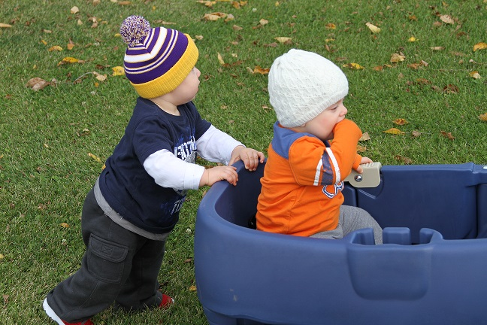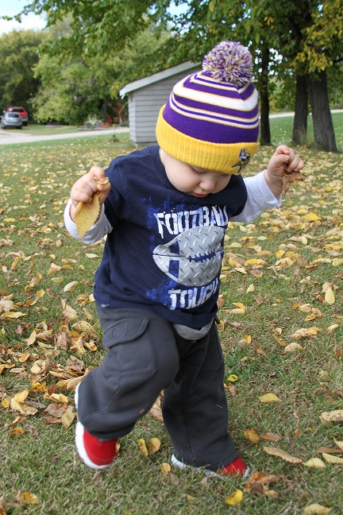

*Consumption of Fruits and Vegetables*

* Consumption of >5 servings of fresh fruits and vegetables per day has declined from 22.8% in 2007 to 18.7% in 2013, although these differences are not statistically significant and are close to the statewide average of 17.7%.



* Beltrami County has a significantly higher percentage of youth consuming 5 of more fresh fruits/vegetables per day than in comparison to the SHIP region.



*Tobacco Use*

* Use of any tobacco product over the past 30 days has decreased steadily and significantly (statistically) over the past six years. From 37% in 2007 to 26% in 2013.
  + However, use of any tobacco product over the past 30 days is still significantly higher than what is found across the rest of the state (state average 18.8%).



* Smokeless tobacco use in Beltrami county is still significantly higher than across the state at 11.8% vs. 7.6%.
* And, use of smokeless tobacco appears to be on the increase after an initial decline from 7.9% in 2007 to 6.2% in 2010. It now stands at 11.8% approximately.



* + In general, over 90% of smokeless tobacco users tend to be male.

