EvaluationGroup, LLC

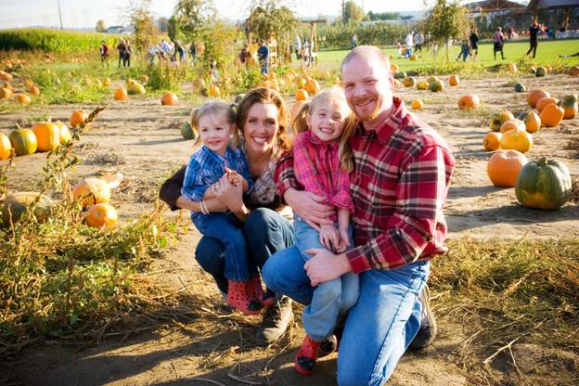
Northwest Minnesota
Community Assessment Collaborative

Regional Summary of
Behavioral Risk Statistics
July
2012

Authored by
Garth Kruger, Ph.D.
Dmitri Poltavski, Ph.D.
Ariana Porter

EvaluationGroup,LLC • 29337 310th Ave NW • Warren, MN 56762
Tel (218) 437-8435 • e-mail gkruger@evaluationgroupllc.com
EXECUTIVE SUMMARY
Purpose of Study: Two research questions were addressed: 1) What do archival statistics collected on regional health indicators reveal as problem areas? 2) What do people around the region think are pressing health concerns?

Methods: A wide range of available archival data was reviewed, including those from the Behavioral Risk Factor Surveillance Survey (BRFSS), Kids Count 2010, Minnesota Student Survey, Census 2010 and numerous others. Additionally, qualitative input was gathered from meetings of the NWCAC and key stakeholders in the local healthcare community. Data reflect Kittson, Marshall, Pennington, Roseau, and Red Lake counties.

Findings:

Demographics: declining population, lower education, higher unemployment, lower median income.
- Slow and steady declines in population year over year have occurred over the past 6 years, continuing a decades-long trend of population exodus from rural areas.
  - More recent data from 2011 suggests that there may be a leveling-off in population decline.

- Educational levels of area residents are substantially lower than in comparison to the rest of the state.
  - Between 47-55% of the population in the region aged 25 and older has less than or equal to a high school education or equivalent compared to 37% of the population statewide.
  - Between 13-19% of the population in the region aged 25 and older has a bachelor’s degree or higher compared to 31.4% of the population statewide.

- Year over year, the unemployment rate within the region tends to be higher than the state average.
  - Red Lake and Marshall Counties have endured the worst unemployment in the region the past three years, whereas Kittson and Roseau have fared better.

- An analysis of commuting area patterns reveals 6 distinct RUCA (rural/urban commuting area) clusters within the region.
  - Residents in both the far eastern and far western halves of Marshall County possess secondary (second largest) work commuting flow destinations to small urban or urbanized areas. In the west residents commute primarily to Crookston/Grand Forks and in the east half Thief River Falls, Warroad and Roseau.
  - Residents of Kittson, Pennington, Roseau and Red Lake Counties primarily live and work within the borders of their own counties.
  - Residents of Kittson and Red Lake counties are in an isolated small rural census tract with no primary flows over 5% to any census bureau defined urbanized area.
  - Greater than 30% of the population in the middle portion of Marshall County and the middle portion of Roseau County commute to a Census bureau defined urban place.

- Median income in the 5-county region ranges between 14-22% lower ($7,843 to $12,317) than the statewide average.
  - Across a working lifetime of 40 years this means that a household in the middle of the income distribution brings home $300,000 to $500,000 less than other households across the state.
  - Median household income in the 5-county region is lowest across a large swath of the area spanning from the northwest corner to the southeast, cutting through Kittson, Roseau and Marshall Counties.
  - While the population is this area is generally the most sparse, they may also be considered higher risk given their proportionally lower incomes compared to the rest of the region.
  - The U.S. Median income from 2006-2010 was $51,914. In Minnesota during the same time frame it was $57,243.

- Regionally, Red Lake County has the greatest percentage (31%) of individuals living at or below 200% of poverty according to the 2011 Minnesota County Health tables

- Red Lake and Marshall County have the highest free/reduced priced lunch rate in the 5-county region, with Roseau being lower than the state average.

Health Problems: the region is medically underserved, adults and youth are overweight, adults smoke, youth chew tobacco at two times the state average, and there are elevated rates of death by heart disease.

- All 5 counties are Health Profession Shortage Areas (HPSAs) for Primary Medical Care Physicians, Mental Health Care providers, and Dentists. Only Roseau County is not a HPSA for dentists
  - Some gaps in emergency medical care may exist north and east of Thief River Falls, and north and east of Hallock.

- The prevalence rate for current smokers (smoked every day or some days in the past 30 days) in Pennington, Kittson and Marshall County (21.3%) is notably higher than the corresponding rate for Minnesota (14.9%).

- 16 percent of students (almost exclusively male) used smokeless tobacco in 2007 which grew to 21.4% in 2010. This use is nearly twice that of the state average in 2010 for the rest of all youth across Minnesota.

- Elevated rates of Oral and Pharyngeal Cancer for Marshall and Pennington counties (that we know of), and elevated Lung and Bronchus Cancer for Kittson county.

- Adults in the region are statistically less likely to be obese but more likely to be overweight.

- Youth from the region are significantly (statistically) more overweight, eat fewer servings of fruits and vegetables, and use more tobacco compared to youth from the rest of the state.
  - Over the past three years these three measures have grown worse.

- MNSS results for area 12th graders indicate that overall, students within the SHIP region are significantly more overweight than other seniors from across the state and furthermore they are significantly more likely to believe they are overweight than other seniors from across the state.

- According to Minnesota Vital Statistics, age adjusted death rates for heart disease reveals that historically, Kittson and Roseau Counties have had a substantially higher rate of heart disease death rates year over year compared to the state on average.

- The percent of all alcohol-related motor vehicle crashes in Marshall and Kittson counties were twice that of the state. For Red Lake County it was 5 times greater.
  - The DWI arrest rate in Pennington and Roseau Counties is approximately twice the state average.

- Low seatbelt use by youth and adults.

- Kittson and Pennington Counties have a higher rate of out-of-home placements than the statewide average. Results for these two counties suggest that there may be a lack of resources, programs, or higher incidence of familial discord, resulting in higher rates of removing children from their homes. 108 children in the region in 2010 were in OOHP (Pennington=35; Roseau=30; Marshall=20; Kittson=15; Red Lake=8).

Lack of accurate information about adults’ state of health.
- Suicide deaths completely unknown. We have data, but it is totally unreliable.
- Multiple Sclerosis prevalence is unknown. There is no system in place for tracking, plus onset is a problem.
- Prevalence of heart disease, depression, diabetes are unknown. We have age adjusted death rates for heart disease.
- Population Health surveys are misleading at worst and at best synthetic guesses.

