STATEWIDE HEALTH IMPROVEMENT PROGRAM (SHIP)

What is SHIP?

Examples of specific SHIP activities include:
Developing farmer’s markets and community gardens for increased access to fresh fruits and vegetables
Identifying cost-neutral, healthier meal options with school food service staff
Procuring and using local foods while establishing school gardens
Initiating or enhancing salad bars in schools and workplaces,
Adding health snack carts and healthy vending in workplaces,
Providing training opportunities along with consultations from registered dieticians for food service workers,
Implementing worksite wellness programs at 21 worksites that increased employee productivity and contributed to employer’s bottom line.
Hosting a Youth Nutrition Summit involving over 130 regional health leaders.

The Statewide Health Improvement Program (SHIP) is designed to reduce the top three preventable causes of death in the United States and thereby help contain growing health care costs. The main efforts of SHIP are increasing the number of healthy food options available in schools and communities, enhancing access to physical fitness opportunities, and preventing tobacco use/exposure. SHIP is financially supported through Minnesota's 2008 health reform law¹.

SHIP at Work in 12 Northwest Minnesota Counties²

Approximately 1.7 million dollars was awarded to implement activities over 30 months between July, 2009 and December, 2011. Activities took place in one hundred sites and impacted approximately 125,000 individuals.

Activity Location | Number of Sites | Number of People Impacted
Schools | 28 | 20,238
Worksites | 21 | 10,298
Communities | 24 | 90,000^
Farmers Markets | 13 | 5,000^
Healthcare Facilities | 14 | Unknown
Totals | 100 | 125,536
^ This is an estimate, exact figures are unknown

Over $190,000 in additional grant monies were provided as a result of SHIP. Funders included: Northwest Minnesota Foundation, Otto Bremer Foundation, United Way of Crookston, General Mills Foundation, and the University of Minnesota.

Key regional partnerships were established, including the University of Minnesota Extension, Northwest Regional Sustainable Development Partnership Northwest Service Cooperative, Marvin’s Windows, Central Boiler, Riverview Health, Lakewood Health Center, Headwaters Food Sovereignty Council, and the Transportation Advisory Council.
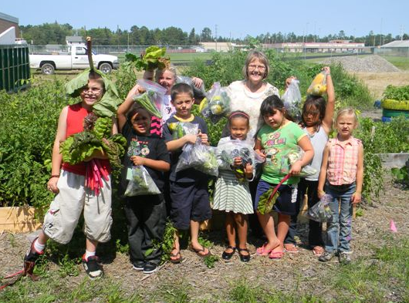
SHIP created an opportunity for local public health staff to build connections with various governing boards and planning committees -such as school boards, wellness committees, city council members and key regional leaders by engaging them in discussions on creating health-focused policies, systems and environments.

Cities throughout the region adopted Active Community Resolutions, thereby comprehensively addressing needs of pedestrians and facilitating active lifestyles when designing streets, parks and trails.

The communities of Warren, Crookston and Fertile are redesigning and enhancing parks as natural play spaces with the purpose of improving health and wellness in children and families by reconnecting them with nature.

Is SHIP Necessary?

- Children Are Not Eating Enough Healthy Foods
- Only 13% of 12th grade students report eating 5 or more fruits and vegetables per day3 (in 8 of 12 NWMN counties). This is significantly lower than the overall state rate of 17.3%
- Nationally for grades 9-12 it is 22.3% (Youth Risk Behavior Survey, 2010).

- Youth Use Tobacco Heavily
- 41% of 12th graders (in 10 out of 12 NWMN counties) have used tobacco products in the past 30 days, which is significantly higher than the state average of 31%.
- Smokeless tobacco use rates in 12th graders are nearly double the state average (22% vs. 12%)
- 15% of adults in the region are considered smokers (11.1% percent smoke every day.

- Adults Are Not Getting Enough Exercise
As a health care professional, it is great to see kids making a healthier choice! SHIP has assisted us in taking a deeper look at preventative initiatives.
-Healthcare Provider

- 64% of Minnesotans are overweight or obese.
- 18% of regional residents do not participate in any weekly physical exercise (state average approximately 13%).

- Limited Health Referral Resource Access and Awareness
- Healthcare providers surveyed throughout the region believe that there are not adequate referral resources for healthy eating, physical fitness, and tobacco cessation opportunities.
- In general, rural communities and counties are more adversely impacted by obesity and tobacco use.

Is SHIP Worth the Cost?
Increasing healthy nutrition and physical activities all contribute to a healthier community. The SHIP grant assisted us in building this foundation. Community members are excited… the momentum is going! I look forward to seeing what’s next!”
- County Commissioner

- An estimated 12,000 quality years of life were gained by area residents.⁴
- Total healthcare costs saved/deferred were an estimated 30 million dollars (range 13-46 million).
  - Reduced incidence of disease by an estimated⁵
    - 17 cases of colorectal cancer;
    - 62 cases of breast cancer;
    - 225 cases of diabetes; and
    - 521 cases of coronary heart disease.
- Estimates are that for every $1 invested, a minimum of $15 in healthcare savings were potentially achieved.
- Exposure to environments that emphasize and support more active lifestyles are one of the most cost effective methods of disease prevention.

What is the Future of SHIP?
- Approximately $650,000 will be available for seven counties⁶ through a second round of funding for activities January 1, 2012-June 30, 2013.
- Local food distribution and storage systems will be enhanced for greater distribution of locally grown fresh foods.
- Farm to School food purchasing coops will be developed in addition to expanding Farmer’s Markets.
- Efforts will continue to examine and expand healthy worksite policy changes.
- Tobacco prevention and cessation opportunities will be expanded to multi-unit housing and university settings.

¹For more information, visit www.health.state.mn.us/healthreform/ship
²Beltrami, Clearwater, Hubbard, Kittson, Lake of the Woods, Mahnomen, Marshall, Norman, Pennington, Polk, Red Lake, Roseau.
³Minnesota Student Survey, 2010
⁴Analysis based on Roux, L., et al, (2008). Cost Effectiveness of Community-based Physical Activity Interventions. American Journal of Preventive Medicine. 35(6). p 578-588.
⁵Healthcare costs saved were calculated using generally accepted public health calculations set forth by the Centers for Disease Control and Prevention and as discussed in Roux et al (2008).
⁶Beltrami, Clearwater, Hubbard, Lake of the Woods, Mahnomen, Norman, Polk.

