**Polk-Norman-MAhnomen CHB Community Health Assessment Executive Summary**

*Quantitative Findings:*

**Demographic Concerns: The region’s population is declining, has generally lower education, higher unemployment, and a lower median income compared to the rest of the state.**

*Population*

* Slow and steady declines in population year after year have occurred over the past 6 years, continuing a decades-long trend of population exodus from rural areas.
  + Recent data suggests that there may be a leveling-off in population decline.

*Education*

* Educational levels of area residents are substantially lower compared to the rest of the state.
  + Between 47-55% of the population in the region aged 25 and older has less than or equal to a high school education or equivalent compared to 37% of the population statewide.
  + Between 13-19% of the population in the region aged 25 and older has a bachelor’s degree or higher compared to 31.4% of the population statewide.

*Employment*

* Year over year, the unemployment rate within Norman-Mahnomen Counties is higher than the state average.

*Income*

* Median income in the three-county area ranges between **14-31% lower ($7,986 to $17,858)** than the statewide median.
  + Across a working lifetime of 40 years this means that a household in the middle of the income distribution brings home $300,000 to $700,000 less than other households across the state.
* Regionally, the greatest percentage of individuals living at or below 200% of poverty are Mahnomen (48%), Norman (33%) and Polk (31%) Counties (Minnesota County Health Tables, 2011).
* Among the highest free/reduced priced lunch rates in the 5-county region are Mahnomen (72%) and Norman (49%) Counties.

**Health Problems: Adults and youth are overweight, adults smoking rates are high, youth chew tobacco at twice the state average and there are elevated rates of death by heart disease.**

Tobacco

* Nineteen percent of 12th grade students (almost exclusively male) used smokeless tobacco in 2010 in Polk County and 23% in Norman County. This use is nearly twice the 2010 state average for 12th graders in Minnesota (12%).

Cancer

* Overall, cancer age adjusted death rates reveal that Norman and Mahnomen Counties appear to have higher cancer death rates than the rest of the state.

Overweight/Obesity

* 62% of adults in the three-county region are either overweight or obese.
* Minnesota Student Survey results for area 12th graders indicate that students within the region are significantly more overweight and eat fewer servings of fruits and vegetables than other seniors from across the state.

Heart Disease

* According to Minnesota Vital Statistics, age adjusted death rates for heart disease reveals that historically, Polk, Norman and Mahnomen Counties have had a substantially higher rate of heart disease death rates year over year compared to the state.

Motor Vehicle Crashes

* The percent of all alcohol-related motor vehicle crashes in Mahnomen (14.5%) and Norman (11%) Counties were over twice that of the state average (5%). For Polk County it was 8.5%.
  + The DWI arrest rate in Mahnomen County is approximately twice the national average.

*Qualitative Findings:*

In the spring of 2013, a re-examination of 24 interviews conducted by SHIP staff in the fall of 2010 was conducted. EvaluationGroup, LLC staff reviewed the numerous interviews, because many of them had gone unanalyzed due to a lack of time and resources with the SHIP 1.0 effort. It was hoped that a review of these interviews might shed additional and useful information. In no particular order of importance, the following areas were described as the most pressing health concerns in their respective communities.

* Alcohol
* Drugs
* Not enough activities
* Obesity
* Eating Habits (bad)
* Diabetes/ Health
* Elderly (greater need for resources)
* Transportation (getting to healthcare providers)
* Cancer (all kinds)
* Health Insurance (lack of)
* Provider recruitment/retention
* Income (low)

***Community Themes and Strengths Discussion Groups***

Over 45 individuals participated in focus groups and individual conversations with public health staff held throughout the summer in Polk, Norman and Mahnomen Counties. Participants were asked to think broadly about the different recurring needs and concerns of clients and the general population served by them and their organizations. An in-depth analysis of the question, “What do you believe are the 2-3 most important issues that should be addressed in order to help further improve the quality of life for people in our community (county)?” is provided on the following page via a concept map. A concept map was developed in order to assist stakeholders in understanding the large volume of information provided. While the qualitative items identified in the concept map are incomplete in terms of exhausting phenomena contributing to the quality of life within the region, at this time it is a highlight of those recurring items viewed by participants as most influential.

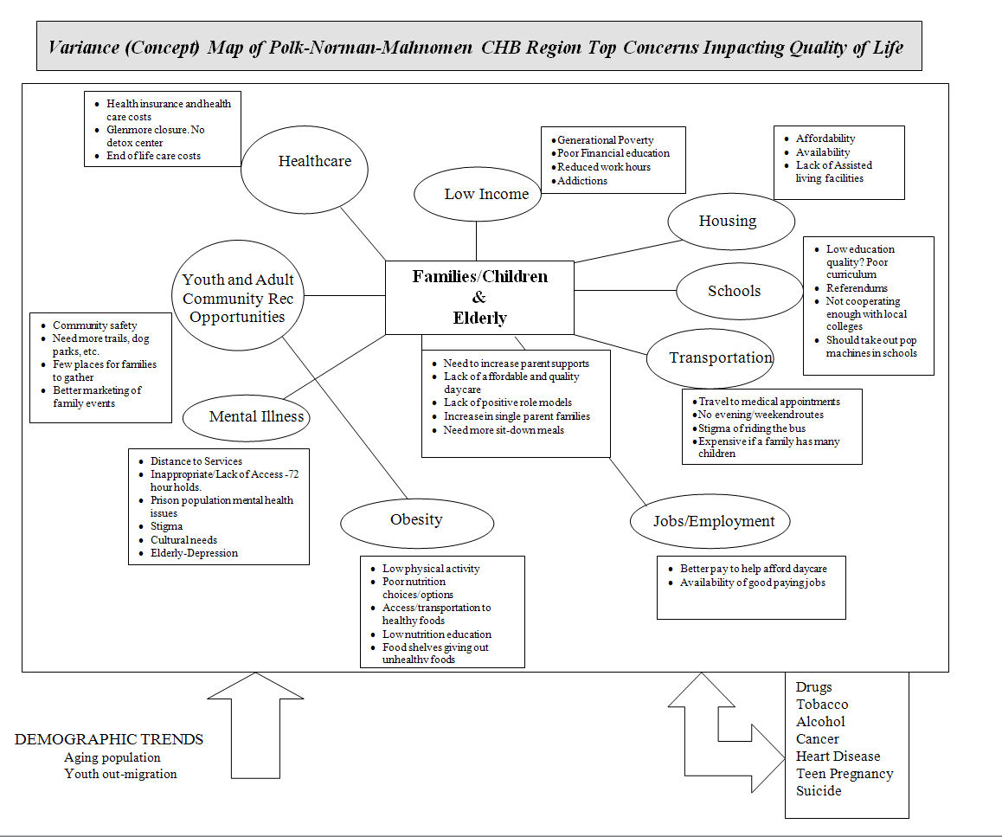

*Quality of Life*

Individuals in the community were asked to complete an 11-item quality of life survey found in the local newspaper, online, at local public health meetings or during client visits. All responses were anonymous.

235 individuals responded to the survey and of those, 204 (87%) reported living in Polk, Norman or Mahnomen County. The remaining respondents worked in but did not live in one of the three counties. All 235 responses were included in the analysis presented.



* 60% of respondents were satisfied with the health care system in the community. Factors considered included access, cost, availability, and quality, options in health care.
* 71% said theirs was a community that was a good place to raise children. Factors considered included school quality, day care, after school programs and recreation.
* 63% felt that the community was a good place to grow old. This included perceived availability of elder-friendly housing, transportation to medical services, churches, shopping; elder day care, social support for the elderly living alone, meals on wheels, etc.
* Only 7% of respondents felt their community was not a safe place to live, and only 6% felt there were not networks of support for individuals and families such as neighbors, support groups, faith community outreach agencies, etc.



* 65% of respondents felt either negative or neutral about economic opportunities within their community.
* 54% of respondents felt neutral or negative that they individually and collectively can make the community a better place to live.
* 50% of respondents felt neutral or negative that community assets were broad-based across multiple sectors of the population.
* 54% felt that levels of mutual trust and respect increase among community partners as they participate in collaborative activities to achieve shared community goals.