EvaluationGroup, LLC

Quin Community
Health Services

2014
Northwest Region
Adult Health Behavior Survey Summary

for

Kittson County

April
2015

Authored by
Garth Kruger, Ph.D.

EvaluationGroup,LLC * 29337 310th Ave NW * Warren, MN 56762
Tel (218) 437-8435 * e-mail gkruger@evaluationgroupllc.com

Executive Summary
- 75% of individuals residing in Kittson County are considered either overweight (40.6%) or obese (34.3%).
  - This is higher than the state average of 64% (37.5 overweight; 26.5%, obese).

- Only a total of 47% of respondents had been told by a healthcare provider that they were overweight or obese.
  - Room for improvement may exist in providing feedback to patients about their weight.

- 86% of respondents indicated they had good health, yet 75% of them were overweight or obese.
  - This raises the question of peoples’ understanding of what constitutes good health.

- In Kittson County, only an estimated 19% of individuals are getting their recommended levels of physical activity whereas 81% are not.
  - 33% percent of survey respondents indicated no physical activity. The state average on this measure is approximately 13%.

- A total of 39% of adults eat five or more servings of fruit and vegetables combined per day which is the daily recommended intake. That total rises to 69% if you include those who get 3-4 servings a day.

- 44% of respondents reported that they had at one time or another been informed by a healthcare provider they had high blood pressure (non-pregnancy related).
  - 40% had been informed they had elevated cholesterol.

- Of the 65% of respondents who consumed alcoholic beverages during the 30 days preceding the survey, 27% of them binge drank (5 or more drinks per sitting male, 4 or more female)

- Study results found that each county remained higher than the statewide average on estimates of diabetes (as was previously suggested in earlier studies).
  - However the extent of these differences seems to have grown worse.

- Approximately 15% of adults in the 5-county region are smokers. Roseau County has the highest rates at 21% and Kittson County has the lowest at 8%. The state average is 14.4%.
  - 53% of smokers tried to quit for one day or longer over the past 12 months.

Recommendations

- Focus additional resources and ideas on areas that develop and encourage physical activity in adult populations.
  - Given the findings on nutrition intake compared to exercise, the data suggest that more immediate gains addressing obesity/overweight issues might be had targeting improved access to physical fitness initiatives.
  - Future survey questions should include asking what type of employment (e.g. day-laborer, office work, etc.) Given the agrarian nature of the region, it is possible that many respondents actually get substantial physical activity through their vocation.
- Health officials should examine and discuss findings presented herein to determine how closely results mirror what they are encountering.
- Future surveys and data collection efforts should explore questions pertaining to e-cigarette use.
- Blood pressure is a significant issue. Thus, conducting blood pressure screenings can continue to be a highly effective way to identify individuals who are both unaware of this dangerous condition and at-risk of complications.
Overall Perceived Health Status

Survey participants were asked: “In general, would you say that your health is …poor, fair, good, very good or excellent?” 86.4% reported “good”, “very good”, or “excellent” health whereas 13.7% reported “fair” or “poor” health.

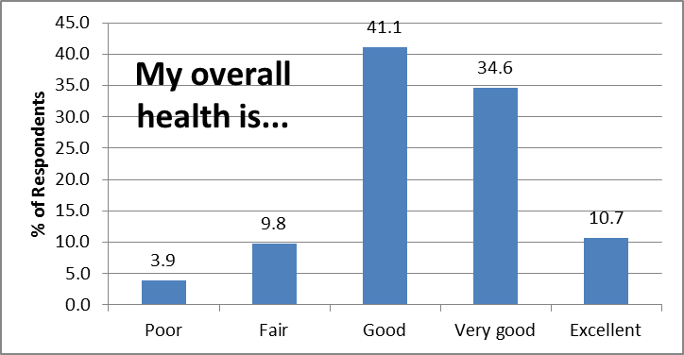
Figure 1

Table 1
Have you ever been told by a doctor, nurse or other health care professional that you had any of the following health conditions?
 | No % | Yes%
High blood pressure | 54.6 | 43.7
High cholesterol or triglycerides | 60.2 | 39.8
Overweight | 63.6 | 36.4
Arthritis | 69.9 | 30.1
Depression | 82.2 | 17.8
Anxiety or panic attacks | 84.4 | 15.6
Heart trouble or angina | 85.6 | 14.4
Cancer | 87.1 | 12.9
Diabetes | 86.1 | 12.5
Obesity | 88.6 | 11.4
Asthma | 91.2 | 8.8
Chronic lung disease | 92.2 | 7.8
Stroke or stroke-related health problems | 95.7 | 4.3

Table 1 highlights the percentage of respondents who reported having the listed chronic health conditions (in descending order from greatest percentage afflicted to least). These findings indicate that blood pressure is a significant issue. Thus, conducting blood pressure screenings can continue to be a highly effective way to identify individuals who are both unaware of this dangerous condition and at-risk of complications.

Weight Status

Survey respondents were asked to report their height and weight. From those data, a Body Mass Index (BMI) was calculated. There are some exceptions to be considered in using BMI to accurately assess the health of individuals; however they are considered a generally accurate measure for the body mass composite a population. As Figure 2 shows below, 74.9% of individuals residing in Kittson County are considered either overweight (40.6%) or obese (34.3%). This is higher than the state average of 64% (37.5 overweight; 26.5%, obese).

Figure 2
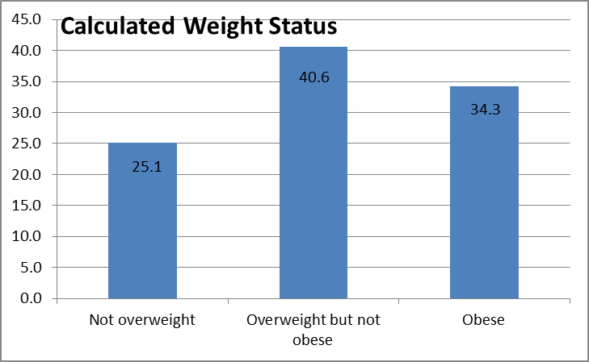

Room for improvement appears to exist in providing feedback to patients about their weight. While 75% of survey respondents were overweight/obese, only a total of 47% had been told by a healthcare provider. Several possibilities for this include: 1) providers are not acknowledging the extent of their patients weight for a variety of reasons, or 2) patients only marginally meet the requirements for overweight and so do not physically appear to be at risk. It is difficult to determine which of these scenarios (or others) exist without further investigation and discussion.
Regardless, respondents perceptions of what constitutes health seem to be skewed because 86% of them responded that they had good health yet 75% are overweight/obese. This raises the question of peoples understanding of what constitutes good health. One suggestion is to consider conducting focus groups exploring how different age groups define what constitutes health and

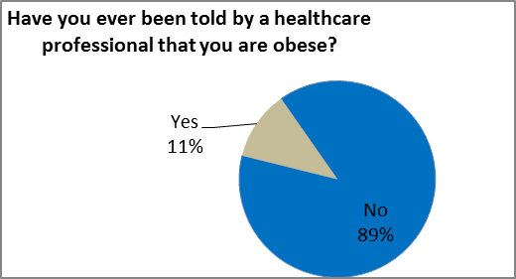
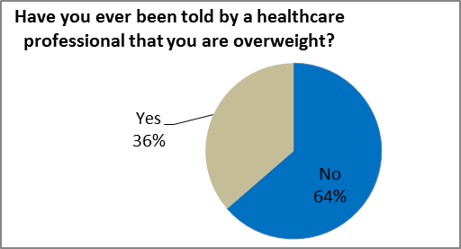
then to design marketing messages that portray what good health is and can provide. When the daily norm is obese/overweight, sometimes it is easy to lose sight of what constitutes healthy.
Figure 4
Figure 3

A further recommendation for future action in this area would be to confer with local healthcare providers to ensure that they are talking to their patients about weight and have available to them a range of referral options –especially as related to physical activity opportunities.
Blood Pressure/Cholesterol

High blood pressure combined with elevated cholesterol levels is a recipe for heart-related problems. The 2014 Regional Health Assessment Survey found that 44% of respondents in Kittson County reported having been informed by a healthcare provider they had high blood pressure (non-pregnancy related). 40% had been informed they had elevated cholesterol.

It is impossible to know from these data whether these findings are the result of significant efforts by primary and public health healthcare providers to reach out to the public to assist them in learning their blood pressure/cholesterol, or if in fact the rates of high blood pressure/cholesterol are greater than reported here because people have not had them checked or were not informed. In the case of blood pressure, the test and information relay is straightforward during a healthcare visit; whereas cholesterol tests involve a blood draw and follow-up. Future surveys should consider asking respondents if they have had their blood pressure/cholesterol checked within the past two years.
Figure 6
Figure 5

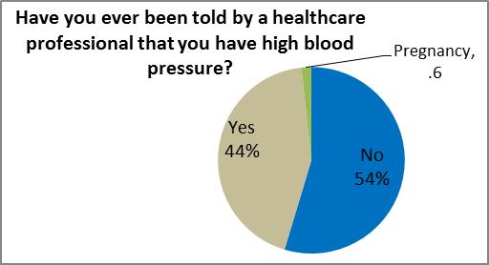
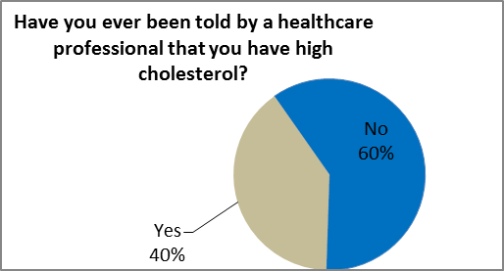

Because high blood pressure and cholesterol are only pre-cursor indicators, elevations are not a guarantee of heart problems. 14% of survey respondents indicated having heart trouble or angina. This may or may not be an accurate reflection of the population.

Results for the 2006-10 timeframe found death rates of 1.18 per 1,000 in Kittson County. These findings were generally in line with the state average of 1.18 during the same period. Suggestions for further research on this issue include discussing current survey findings with primary health care providers to determine if results are similar to their experiences.
Figure 7

Diabetes

The 2014 NW Region Adult Health Behavior Survey found that each county remained higher than statewide average on estimates of diabetes (as was previously suggested via the Behavioral Risk Factor Surveillance Data). However the extent of these differences seems to have grown.
Table 2

Age-Adjusted Estimates of the Percentage of Adults with Diagnosed Diabetes in Minnesota
 | 2009*  % | Difference from State | 2014⁺  % | Difference from State
Statewide | 5.8 | ‘-- | 7.3^ | ‘--
Pennington | 8.6 | +2.8 | 10.7 | +3.4
Kittson | 7.6 | +1.8 | 12.5 | +5.2
Red Lake | 7.2 | +1.4 | 10.6 | +3.3
Marshall | 6.9 | +1.1 | 15.0 | +7.7
Roseau | 6.7 | +0.9 | 10.5 | +3.2
*BRFSS Synthetic estimates: Source: Centers for Disease Control and Prevention.
+2014 NW Region Adult Health Behavior Survey
^2012 Data

In past data analytic studies, local public health staff expressed the belief that BRFSS diabetes estimates were low. The current study suggests that in fact they were correct to question the data. It remains then to answer to what extent the current statistics collected are believed to be accurate. Future public health discussions should examine this issue.

In Kittson County, approximately 12.5% of people have been told by a healthcare professional that they have diabetes. Again, this data may be underestimating the actual incidence of diabetes as it reports only those who have been told they have it by a healthcare professional. Furthermore, we have to assume that the 30% of respondents are generally similar to the 70% of non-respondents on this and all other issues. Unfortunately, there is no way of assessing this truthfulness other than by “truth testing” the data that has been collected. See methodology strengths and weaknesses for more discussion on this topic.
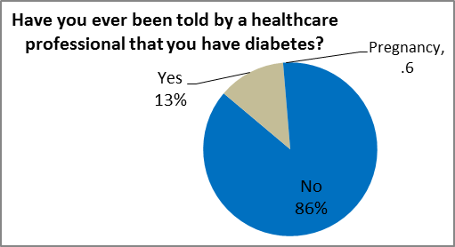
Figure 8

Cancer

Cancer age adjusted death rates from 2009-2013 in Kittson County were generally in line with state averages (see Table 3). Slightly different data examining the same issue through the current study explored the percentage of individuals ever told by a healthcare professional that they have cancer. Approximately 10% reported having ever been diagnosed with cancer overall in the Quin region. By county, those percentages are: Pennington=11%, Kittson=13%, Red Lake=7%, Marshall=14%, and Roseau=6%.
Table 3
Cancer Age Adjusted Death Rates per 1,000 people
 | 2009-13
State | 1.6
Pennington | 1.7
Kittson | 1.6
Red Lake | 1.5
Marshall | 1.5
Roseau | 1.5

Figure 9
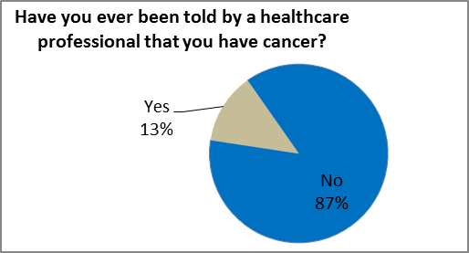
Source: MN Department of Vital Statistics

Physical Activity
A clear path exists for combating disease states created through poor diet and exercise. That path includes identifying the current status of both and then engaging the general public in ways that makes eating healthy and getting physical activity easier.

Participants were asked “during the past 30 days, other than your regular job, did you participate in any physical activity or exercises such as running, calisthenics, golf, gardening, or walking for exercise.” 32.7% of survey respondents indicated “no”. The state average on this measure is approximately 13%.
Figure 10
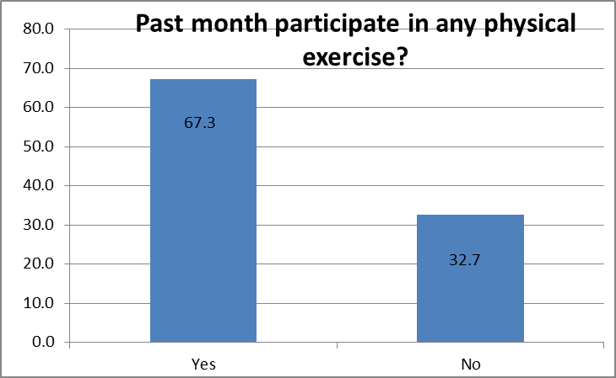

A similar question asked “During an average week, other than your regular job, how many days do you get at least 30 minutes of moderate (or vigorous) exercise. Moderate exercises are defined as those that “cause only light sweating and a small increase in breathing or heart rate, and vigorous are those that “cause heavy sweating and a large increase in breathing or heart rate.” Those responding to this question provided additional support to the idea that the region’s residents do not participate in enough physical activity. For substantial health benefits, adults should do at least 150 minutes (2 hours and 30 minutes) a week of moderate-intensity, or 75 minutes (1 hour and 15 minutes) a week of vigorous-intensity aerobic physical activity, or an
Figure 11
Figure 12
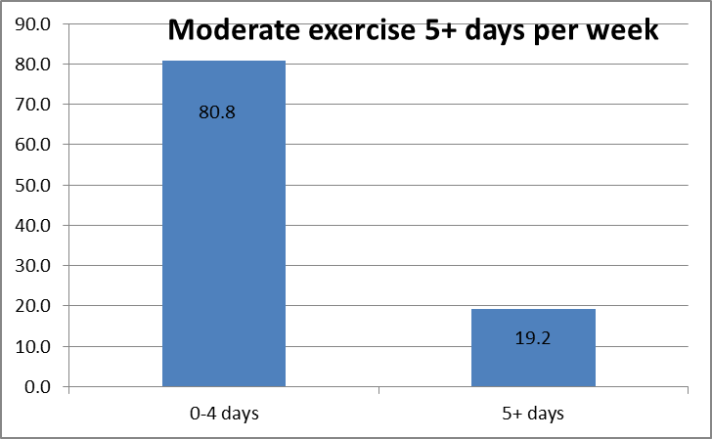
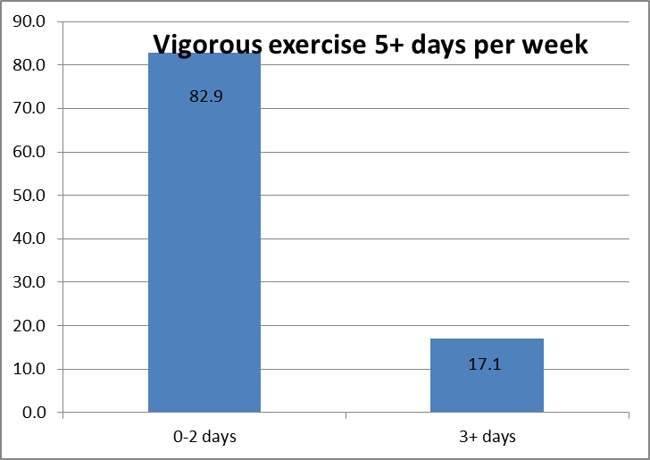
equivalent combination of moderate- and vigorous intensity aerobic activity.

In Kittson County, only an estimated 19.2% of individuals are getting their recommended levels of physical activity; whereas 80.8% are not. A recommendation for health planners in the future is to focus additional resources on areas that develop and encourage physical activity in adult populations. A second suggestion is that future survey questions should include asking what type of employment (e.g. day-laborer, office work, etc.) Given the agrarian nature of the region, it is possible that many respondents actually get lots of physical activity through their vocation.

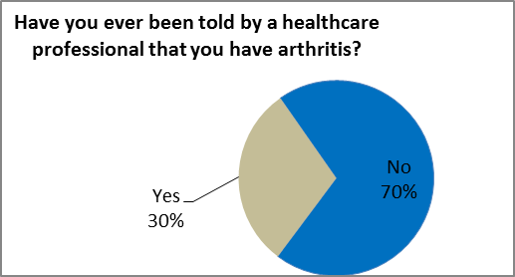
One potential reason for a lack of physical activity is that many of the regions residents may be suffering from arthritis.
Figure 13
Nutrition

A total of 39% of adults eat five or more servings of fruit and vegetables combined per day which is the daily recommended intake. That total rises to 69% if you include those who get 3-4 servings a day, which is-just below the recommended intake.

This data suggests that nearly two-thirds of the population in the region gets a fair amount of nutritious food. Results could be reflective of the numerous fresh fruit/vegetable initiates undertaken in recent years. In any case this data should be a discussion point for local health planners. Given the findings on nutrition intake compared to exercise, the data suggest that more immediate and impactful gains might be had targeting improved access to physical fitness initiatives.
Figure 14
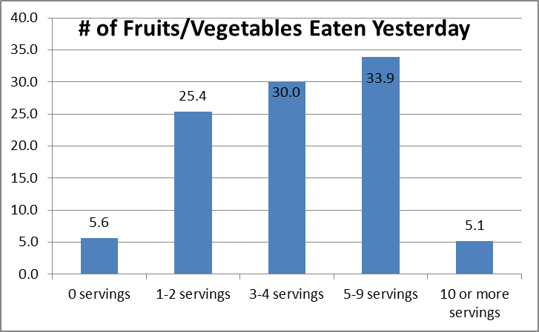

Upon closer examination, more fruits appear to be eaten than vegetables. One possible reason for this may be that fruit juices are counted as part of fruit intake. In general, across the region, vegetables are eaten more often than fruits.
Figure 16
Figure 15
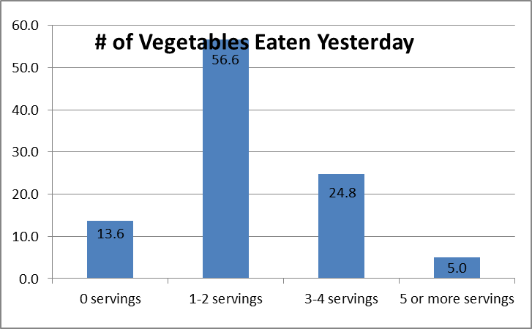
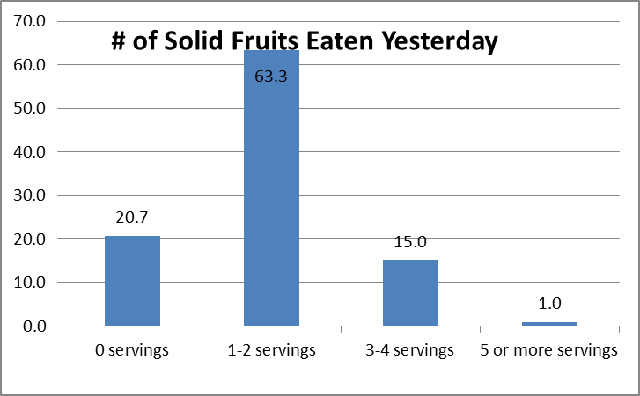
Tobacco Use

Approximately 15% of adults in the Quin service region are smokers whereas 8% of Kittson County residents smoke tobacco regularly. Further, 53.1% of them indicated that during the past 12 months they had stopped smoking for one day or longer because they were trying to quit.

Table 4
 | Marshall County | Kittson County | Pennington County | Red Lake County | Roseau County | MN State
Current smokers | 11% | 8% | 14% | 16% | 21% | 14.4%

Results also found that 2% of Kittson County adults are smokeless tobacco users. This finding is in stark contrast to past Minnesota Student Survey data which has found upwards of 20% use in youth in the past. And while youth populations possess significant differences from adult populations, they often tend to use similar products at higher levels.
Reasons for a lower than expected rate of smokeless tobacco use include: 1) a switch to using e-cigarettes (or other tobacco products) or 2) inaccurate reports of tobacco use. Response rates to this survey for younger males were lower than for other groups. Given that smokeless tobacco use occurs primarily in 18-34 year old males it is possible that the present survey is significantly underestimating use. Health officials should examine and discuss findings to determine how closely results mirror what they are encountering. Furthermore, future surveys and data collection efforts should explore questions pertaining to e-cigarette use.
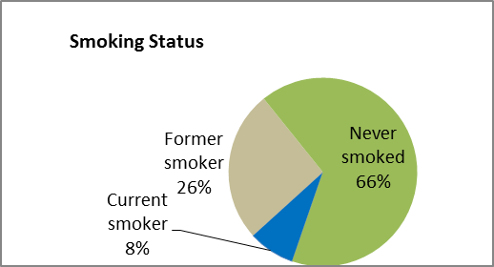
Figure 18
Figure 17
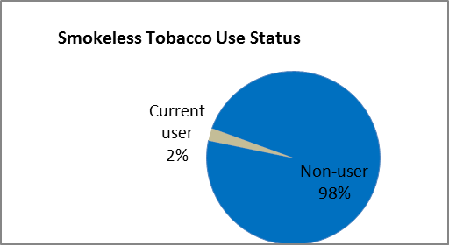

Alcohol Use
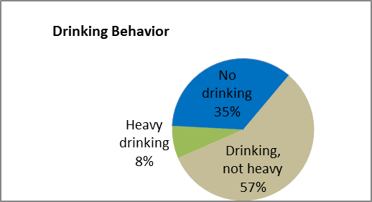
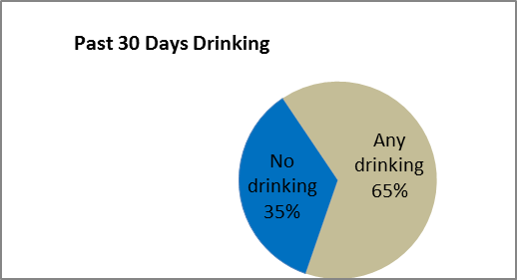
Participants were asked “during the past 30 days, have you had at least one drink of any alcoholic beverage such as beer, wine, a malt beverage or liquor?” Respondents indicated that 35% of them consumed no alcohol.
Figure 19
Figure 20
Those who did drink alcohol were further partitioned into heavy and infrequent consumers. Males and females were classified as heavy drinkers if they had 60 or more drinks (males) or 50 or more (females) in the past 30 days. 8% of respondents met this definition.
Binge drinkers were defined as males who consumed on average 5 or more drinks and females 4 or more drinks on the days they drank. According to these classifications, 27% of respondents were binge drinkers.
Figure 21
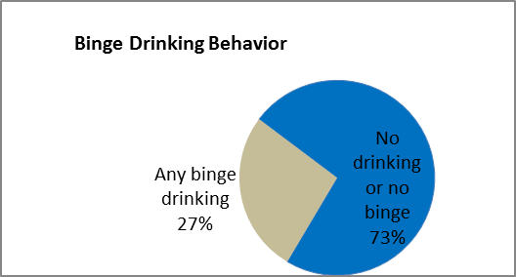

Mental Health

Approximately 16-18% of individuals living in Kittson County have been told at some point in their lives by a healthcare professional that they have panic attacks or depression (see Figure 22 and 23). The good news is that only 10% of people have delayed getting mental health treatment when it was needed. Of the 10%, the delay occurred for a variety of reasons, including perceived lack of severity (67%), cost (37%), and fear of getting treatment (16%). Only 1% indicated transportation was a problem.
Figure 23
Figure 22
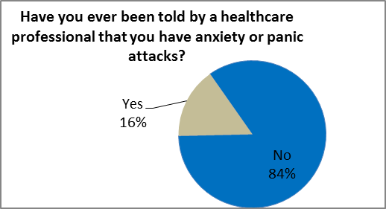
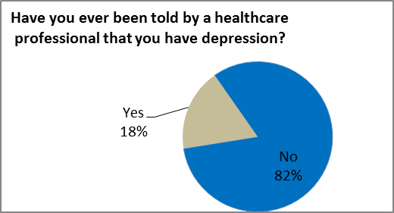

Similarly, over the past 30 days, 17% of respondents expressed feelings of hopelessness, anxiety or loss of interest in things they used to enjoy. Only 2% of respondents indicated other mental health problems. It is unclear if respondents to this question included substance abuse as a mental health problem. Identifying whether these two issues are combined or separate should be addressed in future surveys. Another suggestion is to consider ways to expand physical fitness programs as they have been shown to help improve physical and mental health. While not all individuals with depression or anxiety will be impacted, it provides a place to start.

Figure 24
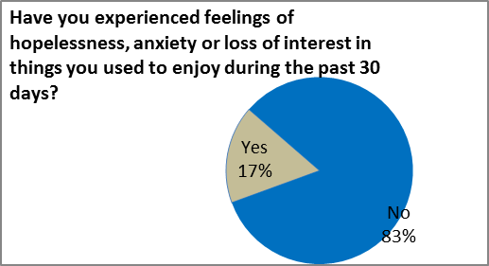
Figure 25
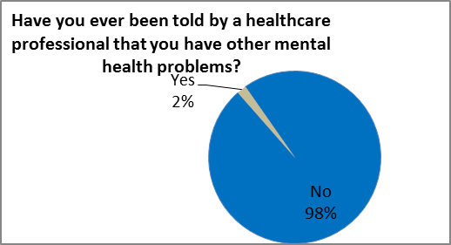

Methods

Survey Instrument

Staff from the public health agencies representing Beltrami, Clearwater, Hubbard, Kittson, Lake of the Woods, Mahnomen, Marshall, Norman, Pennington, Polk, Red Lake and Roseau counties developed the questions for the survey instrument with technical assistance from the Minnesota Department of Health Center for Health Statistics. Existing items from the Behavior Risk Factor Surveillance System (BRFSS) survey and from recent county-level surveys in Minnesota were used to design some of the items on the survey instrument. The survey was formatted by the survey vendor, Survey Systems, Inc. of New Brighton, MN, as a scannable, self-administered English-language questionnaire.

Sample

A two-stage sampling strategy was used for obtaining probability samples of adults living in each of the twelve counties. A separate sample was drawn for each county. For the first stage of sampling, a random sample of county residential addresses was purchased from a national sampling vendor (Marketing Systems Group of Horsham, PA). Address-based sampling was used so that all households would have an equal chance of being sampled for the survey. Marketing Systems Group obtained the list of addresses from the U.S. Postal Service. For the second stage of sampling, the “most recent birthday” method of within-household respondent selection was used to specify one adult from each selected household to complete the survey.

Survey Administration

An initial survey packet that included a cover letter, the survey instrument, and a postage-paid return envelope was mailed October 14-15 2014, to 14400 sampled households (1200 from each county). Two weeks after the first survey packets were mailed (October 28), a reminder postcard was sent to all sampled households, reminding those who had not yet returned a survey to do so, and thanking those who had already responded. Two weeks after the reminder postcards were mailed (November 12), another full survey packet was sent to all households that still had not returned the survey. The remaining completed surveys were received over the next six weeks, with the final date for the receipt of surveys being December 30, 2014.

Completed Surveys and Response Rate

Completed surveys were received from 4012 adult residents of the twelve counties; thus, the overall response rate was 27.9% (4012/14400). County-specific response rates can be found on the next page.

Data Entry and Weighting

The responses from the completed surveys were scanned into an electronic file by Survey Systems, Inc.

To ensure that the survey results are best representative of the adult populations in each of the twelve counties, the data were weighted when analyzed. The weighting accounts for the sample design by adjusting for the number of adults living in each sampled household. The weighting also includes a post-stratification adjustment so that the gender and age distribution of the survey respondents mirrors the gender and age distribution of the adult populations of the twelve counties, according to U.S. Census Bureau 2010 estimates.

County | Completed Surveys | Response Rate
Beltrami | 264 | 22.0%
Clearwater | 342 | 28.5%
Hubbard | 381 | 31.8%
Kittson | 395 | 32.9%
Lake of the Woods | 340 | 28.3%
Mahnomen | 291 | 24.3%
Marshall | 336 | 28.0%
Norman | 379 | 31.6%
Pennington | 295 | 24.6%
Polk | 301 | 25.1%
Red Lake | 364 | 30.3%
Roseau | 324 | 27.0%
Total | 4012 | 27.9%

Strengths and Weaknesses of Current Survey Design Methods

Strengths
- No other adult behavioral risk study focusing on a broad range of health topics has been conducted in the region other than the BRFSS studies (which have traditionally sampled very few individuals in the region)

- Randomized sampling of county residential addresses was used. This procedure helps eliminate data that is either positively or negatively skewed due to selection biases often associated with convenience sampling.

Weaknesses
- It must be assumed (through the process of weighting) that individuals responding to the survey who fall within specific demographic groups (for example males aged 18-34), are not different in any substantial way from their peers within that subgroup who did not respond to the survey. It is possible in some instances where responses within individual demographic categories were small enough that the assumption of similarity between those two groups is of concern. Unfortunately, it is impossible to know to what degree of accuracy is achieved ultimately except to examine each data point individually, in context, and through conversations with experienced healthcare professionals serving the region.

Kittson County 2014 adult survey
Demographic Characteristic
n=390 |  | Frequency | Unweighted Percent | Weighted Percent
Gender
 | Male | 190 | 48.7 | 50.0
 | Female | 200 | 51.3 | 50.0
Age Group
 | 18-34 | 31 | 7.9 | 16.7
 | 35-44 | 30 | 7.7 | 13.3
 | 45-54 | 49 | 12.6 | 20.5
 | 55-64 | 100 | 25.6 | 20.6
 | 65-74 | 82 | 21.0 | 12.9
 | 75+ | 98 | 25.1 | 15.9
White/Of color
 | White | 382 | 97.9 | 97.6
 | Not white | 8 | 2.1 | 2.4
 | Hispanic/Latino | 3
 | American Indian or Alaska Native | 2
 | Black, African or African American | 2
 | Asian or Pacific Islander | 1
 | Other race | 3
Education
 | Less than HS | 26 | 6.7 | 4.3
 | High school/GED | 130 | 33.4 | 31.7
 | Some college/vocational school | 111 | 28.5 | 29.6
 | Associate degree | 30 | 7.7 | 6.8
 | Bachelor's degree | 72 | 18.5 | 23.2
 | Graduate/professional degree | 20 | 5.1 | 4.4
Income
 | <$20,000 | 58 | 16.0 | 10.2
 | $20,000-$34,999 | 67 | 18.5 | 15.6
 | $35,000-$49,999 | 62 | 17.1 | 17.2
 | $50,000-$74,999 | 88 | 24.2 | 26.7
 | $75,000-$99,999 | 46 | 12.7 | 15.8
 | $100,000+ | 42 | 11.6 | 14.5
 | Missing: 6.9% | 27
Employment status
(These do not add up to 100% because respondents could choose more than one status) | Employed | 142 | 36.4 | 45.7
 | Self-employed/farmer | 65 | 16.7 | 23.0
 | Unemployed | 9 | 2.3 | 1.6
 | Homemaker/stay at home parent | 15 | 3.8 | 5.4
 | Student | 1 | 0.3 | 0.2
 | Retired | 169 | 43.3 | 28.0
 | Unable to work | 29 | 7.4 | 6.2

http://www.health.gov/paguidelines/guidelines/summary.aspx

