**Minnesota Student Survey 2007-2013**

**Norman County**

**Methods**

The Minnesota Student Survey (MSS) is a triennial survey of young people regarding a variety of risk and protective factors. The survey asks young people questions about their activities, opinions, behaviors and experiences. It includes questions on an array of priority health-risk behaviors including tobacco use, dietary habits, physical inactivity, substance abuse, school climate, violence and safety concerns, out-of-school activities, and connections to school, community and family.

The survey is administered in schools, alternative learning centers and juvenile correctional facilities across the state. The purpose of the survey has been to:

* Provide data for program planning and evaluation.
* Meet state and federal student survey requirements.
* Address relevant issues confronting students.
* Mark trends over time.
* Involve schools/other educational settings statewide and provide data for local use.

The 2013 MSS was administered in the first half of 2013 to public school students in grades 5, 8, 9 and 11, statewide. All public school districts in Minnesota were invited to participate. Of the 334 public operating districts, 280 agreed to participate (84 percent of public operating school districts).

The survey's methodology changed in 2013 in ways that make it challenging to compare some of the latest results to previous years. From 1992 to 2010, the state surveyed 6th, 9th and 12th graders. In 2013 that changed to 5th, 8th, 9th and 11th graders. Furthermore, a large number of questions were either changed, omitted or added. To the extent that it was possible, variables on the 2013 MNSS were combined or parsed to extract data points that matched responses from previous iterations of the MNSS. The result was that 6 items of interest could be traced back through the 2007 administration and those data, in addition to other enlightening information is included in this review.

Public school student participation was voluntary and surveys were anonymous. Across the state, approximately 66 percent of fifth graders, 71 percent of eighth graders, 69 percent of ninth graders and 62 percent of eleventh graders participated in the 2013 MSS. Overall participation across the four grades was approximately 67 percent of total enrollment.

***In Norman County participation rates were: 91.3 percent of fifth graders, 93.2 percent of eighth graders, 88.6 percent of ninth graders and 70.9 percent of eleventh graders. Overall participation across the four grades was approximately 86.0% percent of total enrollment.***

All schools and districts that participated in the survey followed federal laws regarding parental notification as required by the Family Educational Rights and Privacy Act (FERPA) and the Protection of Pupil Rights Amendment (PPRA). PPRA requires that schools that participate in the survey notify parents of the survey administration, provide parents the opportunity to review the survey instrument, and allow parents to opt their child out of participating.

The description of behavioral health risks in youth for Norman County is based on the culmination of 2007, 2010 and 2013 Minnesota Student Survey data. The summaries that follow provide information on students in grade 12 in 2007 and 2010 whereas in 2013 11th grade student data is presented. Data from older youth is used as they show by far the greatest prevalence of health risk behaviors compared to younger grades. Data on grade 11 and 12 students is deemed to be a relevant and succinct representation of county youth needs given the parameters of the SHIP intervention guidelines.

EvaluationGroup, LLC staff contacted the MN Student Survey administrators and obtained a copy of the raw dataset for further analysis which were used in this report. We are indebted to their generosity for permitting us use of this data in pursuit of improving health in Minnesotans. The survey is made possible through a partnership between the Minnesota Departments of Education, Health, Human Services and Public Safety. These agencies provide funding and staff time to develop, administer and analyze the survey.

Minnesota Student Survey comparisons were made for three of the participating counties between the overall region and statewide statistics. Data for Lake of the Woods County was not available for analysis as they did not partake in the MNSS.

In Norman county, there are four school districts, Norman County East, Norman County West, and Ada/Borup. A broad review of the overall levels of CTG and SHIP activities over the past 6 years suggests that moderate levels of intervention have occurred relative to healthy eating with a greater focus placed on increasing physical activity.

Comparisons between county level percentages and state percentages also include a benchmark SHIP Region percentage value. The SHIP region data includes data from all 12 counties who have been involved in either SHIP and/or CTG since 2009 and include the counties of Norman, Norman, Norman, Lake of the Woods, Roseau, Kittson, Marshall, Red Lake, Pennington, Norman, Mahnomen, and Norman.

**Overall Findings:** Some decrease in the percentage of youth who are overweight is evidenced from 2007 (17.9%) to 2013 (13.6%). Further, the percentage of youth in Norman County who are overweight appears to be slightly higher (13.2%) compared to the statewide average (12.5%). One reason for the lack of continued decline in overweight youth from 2010 where it averaged 7.4% could be because the percentage of youth meeting the guidelines for obese decreased, and thus they meet the criteria for overweight rather than obese. Consumption of 5 or more servings of fresh fruits/vegetables per day has also remained relatively stable across time ranging around 10-11%% over time. Compared to the statewide average of 17.7% there appears to be some room for enhancement in fresh fruit and vegetable consumption opportunities for youth.

Regarding physical activity, the percentage of youth engaging in ‘none at all’ during a typical week has trended lower over time and is currently lower than what is found across the rest of the state (3.3% vs. 12.4%). Further, current assessment of MNSS data on this issue suggests that relative to the rest of the state, Norman may be generally higher in terms of the percentage of youth who are meeting physical activity guidelines (18.0%) compared to the rest of the state (16.6%).

Great success has been experienced in terms of decreasing tobacco use. Self-reported tobacco use in Norman county youth (past 30 days) is down significantly over the past 3 years from 35.2% in 2007 to 8.3% in 2013 (which is lower than the state average of 18.8%). Smokeless tobacco use also appears to be declining, moving from 23.3% in 2007 to 5.0% in 2013.

*Youth Weight Trends*



* Some decrease in the percentage of youth who are overweight is evidenced from 2007 (17.9%) to 2013 (13.6%). Further, the percentage of youth in Norman County who are overweight appears to be slightly higher (13.2%) compared to the statewide average (12.5%).
* One reason for the lack of continued decline in overweight youth from 2010 where it averaged 7.4% could be because the percentage of youth meeting the guidelines for obese decreased, and thus they meet the criteria for overweight rather than obese.



* A decline in the percentage of obese youth in Norman County is indicated, moving from 14.9% in 2007 to 8.5% in 2013. Current rates of obesity in Norman County appear to be slightly lower than the state average of 9.6%.

*Physical Activity*



* ‘No weekly activity’ appears to be trending lower over time and is currently significantly lower than what is found across the rest of the state (3.3% vs. 12.4%).
* Unfortunately, MNSS data do not exist for examining adequate physical activity levels over time as the metrics for measuring such activity have changed. In 2007 and 2010, adequate physical activity definitions included identifying 12th graders who reported ‘participating in either vigorous physical activity for 20 or more minutes per day on 3 or more days in the past 7 days or moderate physical activity for 30 or more minutes per day on 5 or more days in the past 7 days’. Current physical activity guidelines assessed 11th graders and asked: ‘During the last 7 days, on how many days were you physically active for a total of at least 60 minutes per day?’ Because of the lack of similarity in questioning, making comparisons between these data over time was not appropriate.



* On the other hand, current assessment of MNSS data on this issue suggests that relative to the rest of the state, Norman County may be slightly higher in terms of the percentage of youth (18%) who are achieving physical activity guidelines compared to the rest of the state (16.6%).
* Current U.S. Department of Health and Human Service guidelines recommend at least 60 minutes per day of either moderate or vigorous intensity aerobic physical activity and should include vigorous intensity physical activity at least 3 days a week. ([www.health.gov/paguidelines/guidelines/summary.aspx](http://www.health.gov/paguidelines/guidelines/summary.aspx))





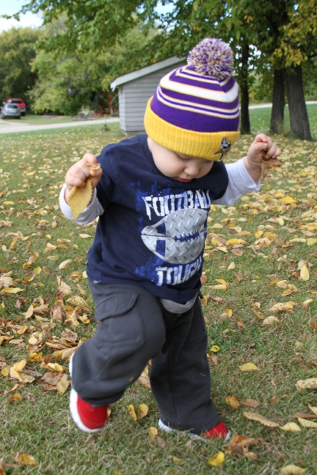

*Consumption of Fruits and Vegetables*

* Consumption of >5 servings of fresh fruits and vegetables per day has held generally constant at around 10-11% over time. Compared to the statewide average of 17.7% there appears to be room for re-doubled efforts to improve fresh fruit and vegetable consumption opportunities for youth.



*Tobacco Use*



* Use of any tobacco product over the past 30 days decreased substantially from 35.2% in 2007 to 8.3% in 2013. This represents a statistically significant drop in use across the county during this time frame.
  + Use of any tobacco product over the past 30 days (8.3%) is lower compared to what is found across the rest of the state (state average 18.8%).



* Smokeless tobacco use appears to be declining after a significant spike, moving from 23.3% in 2010 to 5.0% in 2013.
  + In general, over 90% of smokeless tobacco users tend to be male.
* Smokeless tobacco use in Norman County at 5.0% appears to be slightly less than across the state 7.6%.

